AI-POWERED ENERGY-EFFICIENT STORAGE SYSTEM FOR INTERMITTENT RENEWABLE ENERGY SOURCES

A PROJECT REPORT

Submitted by

PRAJEN S K | 22EE042
T S YESWANTH | 22EE058

in partial fulfillment for the award of the degree
of

BACHELOR OF ENGINEERING
in

ELECTRICAL AND ELECTRONICS ENGINEERING


CHENNAI INSTITUTE OF TECHNOLOGY (AUTONOMOUS)
(Affiliated to Anna University, Chennai) CHENNAI-600 069


ANNA UNIVERSITY: CHENNAI-600 025

MARCH-2026

CHENNAI INSTITUTE OF TECHNOLOGY
(An Autonomous Institution, Affiliated to Anna University, Chennai)

BONAFIDE CERTIFICATE
Certified that this project report “AI-POWERED ENERGY-EFFICIENT STORAGE SYSTEM FOR INTERMITTENT RENEWABLE ENERGY SOURCES” is the bonafide work of PRAJEN S K (22EE042), T S YESWANTH (22EE058) who carried out the project work under my supervision.

SIGNATURE | SIGNATURE
Dr. R. SANKAR M.E, Ph.D. | Dr. THANIGAIVELRAJA.M M.E, Ph.D.
HEAD OF THE DEPARTMENT  Professor | SUPERVISOR  Assistant Professor
Department of Electrical and  Electronics Engineering, | Department of Electrical and  Electronics Engineering,
Chennai Institute of Technology, | Chennai Institute of Technology,
Kundrathur, | Kundrathur,
Chennai-600069. | Chennai-600069.

Certified that the above students have attend of viva voce during the exam held on……………….......

INTERNAL EXAMINER EXTERNAL EXAMIER



Vision of the Institute:

To be an eminent centre for Academia, Industry and Research by imparting knowledge, relevant practices and inculcating human values to address global challenges through novelty and sustainability.

Mission of the Institute:

IM1.To create next generation leader by effective teaching learning methodologies and install scientific spark in them to meet the global challenges.
IM2.To transform lives through deployment of emerging technology, novelty and sustainability.
IM3.To inculcate human values and ethical principles to cater the societal needs.
IM4.To contributes towards the research ecosystem by providing a suitable, effective platform for interaction between industry, academia and R &D establishments.
IM5.To nurture incubation centres enabling structured entrepreneurship and start- ups.



Vision of the Department:



Mission of the Department:

DM1: To provide strong fundamentals and technical skills through effective teaching Learning Methodologies
DM2: To transform lives of the students by fostering ethical values, creativity and novelty to Become entrepreneurs and establish start-ups
DM3: To habituate the students to focus on sustainable resources with optimal usage to ensure the Welfare of the society.
DM4: To provide an ambience for research through collaborations with industry and
academia.

DM5: To inculcate learning of emerging technologies for pursuing higher studies leading to lifelong learning.



Program Educational Objectives (PEOs):

Graduates will be able to
PEO1. Contribute to the industry as an Engineer through sound knowledge acquired In core engineering to develop new processes and implement the solutions for industrial problems.
PEO2. Establish an organization / industry as an Entrepreneur with professionalism, leadership quality, teamwork, and ethical values to meet the societal needs.
PEO3. Create a better future by pursuing higher education / research and develop the sustainable products / solutions to meet the demand.

Program Specific Outcomes (PSOs)
Graduates will be able to

S. No | Programme Specific Outcomes
PSO1 | To analyse, design and develop quality solutions in power electronics by applying the core engineering knowledge for industrial and domestic applications.
PSO2 | To provide solutions for generating clean, safe and sustainable power through multidisciplinary approaches

Program Outcomes with Graduate Attributes

S. No | Graduate Attribute | Program Outcomes
1. | Engineering knowledge | Apply the knowledge of Mathematics and Science with  fundamentals of Mechanical Engineering to solve complex engineering problems.
2. | Problem analysis | Identify, formulate, review research literature, and analyze complex engineering problems related to Mechanical Engineering and reaching substantiated conclusions using first principles of  Mathematics, natural sciences, and engineering sciences.
3. | Design/Development of solutions | Design solutions for complex engineering problems related to Mechanical Engineering and develop processes that meet the specified needs with appropriate consideration for the public health and safety, and the cultural, societal, and environmental  considerations.
4. | Conduct  investigations of complex problems | Use research-based knowledge and research methods including  design of experiments, analysis and interpretation of data, and synthesis of the information to provide valid conclusions.
5. | Modern Tool usage | Create, select, and apply appropriate techniques, resources, and modern engineering and IT tools including prediction and modeling to Mechanical Engineering related complex engineering activities  with an understanding of the limitations.
6. | The Engineer and society | Apply reasoning informed by the contextual knowledge to assess societal, health, safety, legal and cultural issues and the consequent responsibilities relevant to the Mechanical Engineering professional  practice.
7. | Environment and sustainability | Understand the impact of the professional Mechanical Engineering  solutions in societal and environmental contexts, and demonstrate the knowledge of, and need for sustainable development.
8. | Ethics | Apply ethical principles and commit to professional ethics and  responsibilities and norms of the engineering practice.
9. | Individual and team  Work | Function effectively as an individual, and as a member or leader in  diverse teams, and in multidisciplinary settings.
10. | Communication | Communicate effectively on complex engineering activities with the engineering community and with society at large, such as, being able to comprehend and write effective reports and design documentation, make effective presentations, and give and receive  clear instructions.
11. | Project management and finance | Demonstrate knowledge and understanding of the engineering and management principles and apply these to one’s own work, as a member and leader in a team, to manage projects and in  multidisciplinary environments
12. | Life-long learning | Recognize the need for, and have the preparation and ability to engage in independent and life-long learning in the broadest  context of technological change.
Course Outcomes:

CO | Outcomes
CO1 | Ability to identify, formulate, design, interpret, analyze and provide solutions to complex engineering and societal issues by applying knowledge gained on basics of science and Engineering.
CO2 | Ability to choose, conduct and demonstrate a sound technical knowledge of their selected project topics in the field of power components, protection, high voltage, electronics, process automation, power electronics and drives instrumentation and control by exploring suitable engineering and IT tools.
CO3 | Ability to understand, formulate and propose new learning algorithms to solve engineering  and societal problems of moderate complexity through multidisciplinary projects understanding  commitment towards sustainable development.
CO4 | Ability to demonstrate, prepare reports, communicate and work in a team as a member/leader by adhering to ethical responsibilities.
CO5 | Ability to acknowledge the value of continuing education for oneself and to stay up with  technology advancements.

Sustainable Development Goals (SDG)

SDG  Number | SDG Title | Relevance with Project
SDG 3 | Good Health and Well- being | The project directly contributes to improved patient care by enabling continuous real-time monitoring of vital parameters. This allows for timely detection of anomalies and faster medical intervention, thereby enhancing overall health outcomes.
SDG 9 | Industry, Innovation, and Infrastructure | The project leverages innovative IoT technologies to integrate multiple sensors within a wearable glove. This approach fosters innovation in healthcare technology and strengthens the infrastructure for remote monitoring.
SDG 11 | Sustainable Cities and Communities | By enabling remote patient monitoring, your system reduces the need for frequent hospital visits and supports smart healthcare practices. This contributes to building more resilient and sustainable communities, particularly in urban areas where healthcare resources can be optimized.
SDG 12 | Responsible Consumption and Production | The project emphasizes an energy-efficient design through the use of low-power sensors and optimized power management strategies. This not only reduces energy consumption but also supports sustainable production practices in the development of medical devices.

ACKNOWLEDGEMENT

We express our gratitude to our Chairman Shri.P.SRIRAM and all trust members of Chennai institute of technology for providing the facility and opportunity to do this project as a part of our undergraduate course.

We are grateful to our Principal Dr.A.RAMESH M.E, Ph.D. for providing us the facility and encouragement during the course of our work.

We sincerely thank of Head of the Department, Dr.R.SHANKAR M.E,Ph.D Department of Electrical and Electronics Engineering for having provided us valuable guidance, resources and timely suggestions throughout our work.

We sincerely thank our Project Guide, Dr.THANIGAIVELRAJA.M M.E, Ph.D. Assistant Professor, Department of Electrical and Electronics Engineering for having provided us valuable guidance, resources and timely suggestions throughout our work.

We would like to extend our sincere thanks to the Department Coordinators and all the Faculty Members of the Department of Electrical and Electronics Engineering for their valuable suggestions, guidance, and kind cooperation throughout the course of this project, which greatly contributed to the successful completion of our work.

We wish to acknowledge the help received from the Lab Instructors of the Department of Electrical and Electronics Engineering and others for providing valuable suggestions and for the successful completion of the project.

ABSTRACT
The increasing integration of renewable energy sources into modern power grids introduces challenges such as intermittency, voltage instability, and limitations of conventional energy storage systems. To address these issues, this project proposes an AI-powered energy-efficient storage system designed to enhance grid stability, safety, and energy utilization through the integration of embedded hardware, power electronics, and artificial intelligence.
The system is centered on a 12 V, 9 Ah lithium-ion battery pack with an IoT-enabled Battery Management System (BMS) based on the ESP32 microcontroller. The BMS performs real-time monitoring of voltage, current, and temperature while ensuring operational safety through overcharge, over-discharge, short-circuit protection, and cell balancing. Thermal management is implemented using busbar-embedded thermocouples combined with PWM-controlled active cooling to prevent hotspot formation and maintain safe operating temperatures.
AI-based prediction models, including hybrid LSTM-GRU networks with transfer learning, enable accurate State-of-Charge (SOC) and State-of-Health (SOH) estimation, achieving over 92% accuracy across 200 charge–discharge cycles. A 6-pulse three-phase MOSFET inverter converts 12 V DC to 415 V AC, supporting both grid-connected and islanded operation with switching latency below 50 ms.
Energy flow is optimized using reinforcement learning-based dispatch, achieving approximately 92% efficiency and reducing grid downtime by nearly 40%. MQTT-based IoT communication with cloud storage enables remote monitoring and predictive maintenance, providing a reliable and intelligent storage solution aligned with sustainable renewable grid integration.

TABLE OF CONTENTS

CHAPTER NO. | TITLE | Page No.
 | ABSTRACT | x
 | LIST OF TABLES | xiv
 | LIST OF FIGURES | xv
 | LIST OF ABBREVIATIONS & SYMBOLS | xvi
 | PO&PSO’S ATTAINED | xx
1 | INTRODUCTION | 1
1.1 | Renewable Energy Integration and the Need for Energy Storage | 1
1.2 | Limitations of Conventional Battery Management Systems | 2
1.3 | Proposed AI-Based Battery Storage and Management System | 3
2 | PROBLEM STATEMENT | 4
2.1 | Challenges in Renewable Energy Storage Systems | 4
2.2 | Limitations of Conventional Battery Management and Monitoring | 4
2.3 | Need for an Intelligent Battery Storage and Management System | 5
2.4 | Key Problems Addressed | 6
3 | EXISTING SYSTEMS | 8
3.1 | Conventional Renewable Energy Storage Systems | 8
3.2 | Limitations of Conventional Battery Management Systems | 8
3.3 | Thermal and Energy Management Limitations | 9
3.4 | Research Gap in Existing Systems | 10
4 | PROJECT OBJECTIVES | 11
5 | LITERATURE SURVEY | 17
6 | PROPOSED SOLUTION | 24
6.1 | Intelligent Battery Management System | 24
6.2 | Thermal Fault Detection System | 25
6.3 | AI-Based Battery Analytics | 26
6.4 | Power Conversion and Harmonic Filtering | 27
6.5 | Intelligent Cooling and Energy Dispatch | 27
6.6 | Overall System Capability | 28
7 | METHODOLOGY | 29
7.1 | Battery State Estimation | 30
7.2 | Thermal Fault Detection and Management | 31
7.3 | Inverter Operation and Grid Integration | 33
7.4 | Intelligent Energy Dispatch | 34
8 | TECHNOLOGY STACK | 36
8.1 | Hardware Components | 36
8.1.1 | Battery Pack Assembly | 37
8.1.2 | Thermal Sensing and Management | 38
8.1.3 | Inverter and Power Conversion | 39
8.1.4 | Monitoring and Control Interface | 41
8.2 | Software Components | 42
8.2.1 | Firmware and Embedded Control | 43
8.2.2 | AI/ML Frameworks and Models | 44
8.2.3 | Simulation and Testing Tools | 46
9 | PROJECT ANALYSIS | 47
9.1 | Experimental Results | 47
9.1.1 | Battery State Estimation (SOC and SOH) | 47
9.1.2 | Thermal Fault Detection and Management | 49
9.1.3 | Inverter and Energy Dispatch Performance | 50
9.2 | Discussion | 51
9.2.1 | Technical Feasibility | 51
9.2.2 | Commercial Feasibility | 51
9.3 | Operational Flow Analysis | 52
9.4 | Novelty and Innovation | 53
9.5 | Future Scope | 54
9.6 | Overall Performance | 54
10 | PROJECT PHOTOS | 55
11 | CONCLUSION | 61
12 | APPENDICES | 62
13 | REFERENCES | 70

LIST OF TABLES
Table No. | Description | Page No.
Table 7.1 | AI Enhancement | 36
Table 7.2 | Thermal Fault Detection and Management | 37
Table 7.3 | Inverter Operation and Grid Integration | 38
Table 8.1 | Inverter and Power Conversion | 44
Table 8.2 | Simulation and Testing Tools | 48
Table 9.1.1 | Battery State Estimation (SOC and SOH) | 50
Table 9.1.3 | Inverter and Energy Dispatch Performance | 51
Table 9.2.1 | Commercial Feasibility | 52
Table 9.6.1 | Overall Performance Summary | 54
Table 12.1.1 | SOC Estimation Model | 61
Table 12.1.2 | Battery Degradation Model | 61
Table 12.1.3 | Thermal Diffusion Model | 62
Table 12.2.1 | Dataset Information | 62
Table 12.3.1 | Hardware Components | 63
Table 12.4.1 | AI Model Architecture | 63
Table 12.5.1 | Inverter Electrical Performance | 64
Table 12.6.1 | Communication System | 64
Table 12.7.1 | Safety Protection Logic | 64
Table 12.8.1 | Software Development Tools | 65

LIST OF FIGURES
Figure No. | Description | Page No.
Figure 1.1 | Renewable Energy Integration and the Need for Energy Storage | 13
Figure 2.1 | Challenges in Renewable Energy Storage Systems | 18
Figure 4.1 | Project Objectives | 24
Figure 6.1 | Proposed Solution | 32
Figure 6.2 | AI-Based Battery Analytics | 33
Figure 7.1 | Intelligent Energy Dispatch | 40
Figure 8.1.1 | Battery Pack Assembly | 41
Figure 8.1.2 | Thermal Sensing and Management | 42
Figure 8.1.3 | Inverter and Power Conversion | 43
Figure 8.2.1 | Monitoring and Control Interface | 45
Figure 8.2.2 | Firmware and Embedded Control | 46
Figure 8.2.3 | AI/ML Frameworks and Models | 47
Figure 10.1 | Inverter Architecture | 55
Figure 10.2 | BMS Architecture | 56
Figure 10.3 | Lithium Battery Pack | 56
Figure 10.4 | Inverter Circuit | 57
Figure 10.5 | BMS Circuit | 57
Figure 10.6 | Software User Interface View – 1 | 58
Figure 10.7 | Software User Interface View – 2 | 58
Figure 10.8 | Software User Interface View – 3 | 59

LIST OF ABBREVIATIONS
Abbreviations | Description
ADC | Analog-to-Digital Converter
AI | Artificial Intelligence
BMS | Battery Management System
CO | Course Outcomes
DM | Department Mission (DM1–DM5)
ESS | Energy Storage Systems
GRU | Gated Recurrent Unit
IM | Institute Mission (IM1–IM5)
IoT | Internet of Things
LC | Inductor-Capacitor (filter)
Li-ion | Lithium-ion
LSTM | Long Short-Term Memory
MPPT | Maximum Power Point Tracking
MQTT | Message Queuing Telemetry Transport
OTA | Over-The-Air
PEO | Program Educational Objectives
PID | Proportional-Integral-Derivative
PINN | Physics-Informed Neural Network
PSO | Program Specific Outcomes
PWM | Pulse Width Modulation
PV | Photovoltaic
RMSE | Root Mean Square Error
ROI | Return on Investment
RUL | Remaining Useful Life
SDG | Sustainable Development Goals
SOC | State-of-Charge
SOH | State-of-Health
THD | Total Harmonic Distortion

LIST OF SYMBOLS
Symbols | Description
$$α$$ | Degradation constant (≈ 0.001 per cycle) or thermal diffusivity
$$Cₙ$$ | Nominal battery capacity (9 Ah)
$$e\left(t\right)$$ | Error signal (PID controller)
$$η$$ | Coulomb efficiency (95 %)
$$I(τ)$$ | Current at time τ
$$Kₚ, Kᵢ$$ | Proportional and integral gains (PID controller)
$$n$$ | Cycle number
$$Q₀$$ | Initial battery capacity
$$Q_{\text{actual}}$$ | Actual (measured) battery capacity
$$Qₙ$$ | Battery capacity after n cycles
$$Q_{\text{nominal}}$$ | Nominal battery capacity
$$Q_{\text{gen}}$$ | Joule heating term (= I²R)
$$\text{SOC}(t)$$ | State-of-Charge at time t
$${\text{SOC}}_{\text{coulomb}}$$ | Coulomb-counting component of SOC
$${\text{SOC}}_{\text{final}}$$ | Final fused SOC
$${\text{SOC}}_{\text{voltage}}$$ | Voltage-based component of SOC
$$T_{i}$$ | Temperature of cell i
$$u(t)$$ | Control output (PID)
$$z$$ | z-score (thermal anomaly detection)
$$μ$$ | Mean temperature
$$σ$$ | Standard deviation of temperature
$$\frac{∂T}{∂t}$$ | Rate of temperature change
$$∇^{2}T$$ | Laplacian of temperature (heat diffusion equation)

PO&PSO’S ATTAINED

PO.No | Graduate Attribute | Attained | Justification
PO 1 | Engineering knowledge | Yes | Applied core concepts of electrical engineering, power electronics, embedded systems, control systems, and machine learning for designing the intelligent energy storage system.
PO 2 | Problem analysis | Yes | Analyzed critical challenges in renewable energy integration such as intermittency, battery degradation, thermal risks, and inefficient dispatch mechanisms.
PO 3 | Design / Development of solutions | Yes | Designed and implemented a complete AI-powered energy storage solution integrating BMS, inverter, thermal management, and intelligent energy dispatch.
PO 4 | Conduct investigations of complex problems | Yes | Performed laboratory testing, simulations (MATLAB, PyBaMM), and AI model validation to evaluate system performance under varying load and fault conditions.
PO 5 | Modern tool usage | Yes | Utilized modern engineering tools such as ESP32, Arduino IDE, TensorFlow, MATLAB/Simulink, PyBaMM, MQTT, and cloud databases for system development and analysis.
PO 6 | The engineer and society | Yes | Contributes to societal needs by enabling reliable renewable energy integration, supporting rural electrification and sustainable energy access.
PO 7 | Environment and sustainability | Yes | Promotes clean energy usage, improves battery lifespan, and reduces energy wastage through efficient storage and intelligent energy management.
PO 8 | Ethics | Yes | Ensured safe system operation through fault detection, protection mechanisms, and responsible use of AI for critical infrastructure.
PO 9 | Individual and team work | Yes | Successfully completed through collaborative teamwork involving hardware design, software development, and system integration.
PO 10 | Communication | Yes | Demonstrated through technical documentation, presentations, design reviews, and project reporting.
PO 11 | Project management and finance | Yes | Project was executed within defined cost constraints and academic timeline, following structured planning and task allocation.
PO 12 | Life-long learning | Yes | Encouraged continuous learning in emerging areas such as AI in energy systems, IoT, smart grids, and battery analytics.

PSO.No | Graduate Attribute | Attained | Justification
PSO 1 | To analyze, design and develop quality solutions in power electronics by applying core engineering knowledge for industrial and domestic applications | Yes | The project applies power electronics, embedded systems, sensing, and control techniques to design a smart inverter and battery management system for real-world energy applications.
PSO 2 | To provide solutions for generating clean, safe, and sustainable power through multidisciplinary approaches | Yes | The system integrates renewable energy sources with AI, IoT, thermal modeling, and reinforcement learning to deliver a sustainable, intelligent, and safe energy storage solution.

CHAPTER 1 INTRODUCTION

Renewable Energy Integration and the Need for Energy Storage

The increasing global adoption of renewable energy sources such as solar photovoltaic (PV) and wind power is transforming modern electrical power systems. These renewable sources provide clean and sustainable alternatives to fossil fuel-based generation. However, their inherent intermittency and variability create challenges in maintaining grid stability, reliability, and power quality. Fluctuations in solar irradiance and wind speed lead to variations in power generation, which can cause voltage instability, frequency deviations, and inefficient energy utilization, particularly in distributed energy systems and microgrids [18],[19].

Energy Storage Systems (ESS) play a crucial role in addressing these challenges by decoupling energy generation from consumption. By storing excess renewable energy and supplying it during periods of demand, ESS improves grid flexibility, stabilizes power output, and enhances the reliability of renewable-based power systems [18]. Among various storage technologies, lithium-ion (Li-ion) batteries are widely used due to their high energy density, fast response time, high efficiency, and long cycle life [16],[17]. As a result, Li-ion batteries are extensively deployed in renewable energy storage, electric vehicles, and smart grid applications [10]. Figure 1 shows a combined chart of failure incidents, cumulative deployments, and failure rate from 2018 to 2023, illustrating decreasing failure rate as deployments increase.

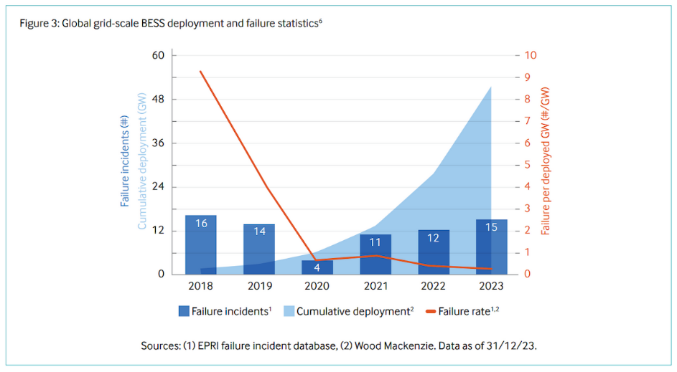
Figure 1.1 Renewable Energy Integration and the Need for Energy Storage
Combined chart showing failure incidents, cumulative deployments,
and decreasing failure rate from 2018–2023.

Limitations of Conventional Battery Management Systems

Despite their advantages, lithium-ion battery systems face operational and safety challenges. Traditional Battery Management Systems (BMS) primarily rely on monitoring basic parameters such as voltage, current, and surface temperature. However, these systems often lack advanced predictive capabilities for accurate estimation of key battery parameters such as State-of-Charge (SOC) and State-of-Health (SOH), especially under dynamic operating conditions [8],[11].
Measurement inaccuracies, battery aging, and varying load conditions can reduce the reliability of these estimations over time. In addition, conventional systems provide limited capability for early fault detection, degradation prediction, and intelligent energy management [9],[13]. Thermal management also remains a critical concern, as localized hotspots and uneven temperature distribution within battery packs can accelerate degradation and potentially lead to hazardous conditions such as thermal runaway [14],[20].

1.3 Proposed AI-Based Battery Storage and Management System

To address these challenges, this project proposes an AI-Powered Energy-Efficient Battery Storage and Management System for Renewable Grids. The system is built around a 12 V, 9 Ah lithium-ion battery pack integrated with an IoT-enabled Battery Management System based on the ESP32 microcontroller. The hardware platform performs real-time monitoring of pack voltage, current, and temperature using embedded sensors and thermocouples integrated within copper busbars for improved hotspot detection.

An AI-based analytics platform developed using Python processes battery telemetry data to derive key indicators such as voltage imbalance, thermal stress, and average cell voltage. A hybrid State-of-Charge estimation method combining Coulomb counting and voltage-based techniques improves charge estimation accuracy [8],[10]. Machine learning models are also used to predict battery degradation, enabling estimation of State-of-Health (SOH) and Remaining Useful Life (RUL) for predictive maintenance [12],[13].

The stored energy is delivered through a 6-pulse three-phase MOSFET-based inverter, which converts DC power to AC power suitable for grid and load applications. Additionally, an AI-based energy dispatch optimization algorithm intelligently manages power flow between solar PV generation, battery storage, and the grid [22],[24].

By integrating embedded sensing, IoT monitoring, machine learning analytics, and intelligent control strategies, the proposed system enhances battery safety, improves renewable energy utilization, and supports the development of reliable and sustainable energy storage systems [18],[25].

CHAPTER 2 PROBLEM STATEMENT

Challenges in Renewable Energy Storage Systems

The increasing integration of renewable energy sources such as solar photovoltaic (PV) and wind power into modern electrical grids has introduced several operational challenges. Unlike conventional power plants that provide stable and controllable output, renewable energy generation is highly dependent on environmental conditions. Variations in solar irradiance and wind speed lead to fluctuations in power generation, which may cause voltage instability, frequency deviations, and inefficient utilization of generated energy [18],[19]. These issues become more significant in distributed energy systems and microgrids where maintaining continuous and reliable power supply is critical [25].

Energy Storage Systems (ESS), particularly lithium-ion battery technologies, are widely used to balance renewable energy generation and load demand. Lithium-ion batteries offer advantages such as high energy density, fast charge–discharge response, and long cycle life [16],[17]. However, existing battery storage systems still face several technical limitations that affect their efficiency, reliability, and safety in renewable energy applications [10].

2.2 Limitations of Conventional Battery Management and Monitoring

Conventional Battery Management Systems (BMS) mainly rely on basic monitoring of parameters such as voltage, current, and temperature. While these measurements provide essential operational information, they lack advanced predictive capabilities required for intelligent battery monitoring. As a result, traditional systems often struggle to accurately estimate critical parameters such as State-of-Charge (SOC) and State-of-Health (SOH), especially under varying load conditions and long-term battery aging [8],[11].

Thermal management is another major challenge in lithium-ion battery systems. Localized heating within battery cells may remain undetected due to limited internal temperature sensing and insufficient diagnostic mechanisms. Passive cooling techniques and surface-level monitoring methods may fail to identify internal thermal stress at an early stage [14]. This can accelerate battery degradation and potentially lead to hazardous conditions such as thermal runaway [20].

In addition, commonly used SOC estimation techniques such as Coulomb counting and voltage-based methods accumulate errors over time and do not effectively account for dynamic operating conditions, environmental factors, or battery aging [8],[10]. Furthermore, many existing renewable energy storage systems lack intelligent energy management strategies. Power flow between renewable sources, battery storage, and the utility grid is typically controlled through rule-based approaches that cannot dynamically adapt to changing system conditions, leading to inefficient energy utilization [22].

2.3 Need for an Intelligent Battery Storage and Management System

Another major limitation of conventional battery monitoring systems is the absence of predictive analytics and real-time system diagnostics. Without advanced data-driven models, it becomes difficult to detect early signs of battery degradation, forecast remaining battery life, or identify abnormal operating conditions [12],[13]. This results in reactive maintenance practices, increased operational risks, and reduced battery lifespan [21].

Therefore, there is a need for an intelligent battery storage and management system that integrates advanced sensing technologies, machine learning-based analytics, digital twin simulation, and adaptive energy management strategies [1],[4]. Such a system should be capable of accurately estimating battery states, predicting degradation trends, detecting thermal faults at an early stage, and optimizing energy dispatch among renewable sources, battery storage, and the utility grid [1],[4]

2.4 Key Problems Addressed

Modern renewable energy storage systems face several technical challenges related to battery monitoring, safety, and intelligent energy management. One of the primary issues is the difficulty in detecting localized thermal hotspots inside lithium-ion battery cells, which can lead to thermal runaway and safety hazards if internal temperature variations are not properly monitored [16],[17],[20]. Conventional battery monitoring methods also suffer from inaccurate State-of-Charge (SOC) estimation, mainly due to cumulative errors in techniques such as Coulomb counting and basic model-based observers [8],[10]. In addition, existing systems often lack reliable State-of-Health (SOH) prediction and long-term degradation modeling, which are critical for estimating battery lifespan and ensuring reliable operation [9],[13]. Another major limitation is the absence of AI-driven predictive analytics capable of estimating Remaining Useful Life (RUL) and identifying early signs of performance degradation [12],[21].

From an energy management perspective, many renewable storage systems still rely on rule-based dispatch strategies, which result in inefficient utilization of available energy resources and reduced system flexibility [22]. These systems also lack intelligent coordination between solar photovoltaic sources, battery storage units, and grid supply, limiting their effectiveness in microgrid environments [24]. Furthermore, the absence of predictive maintenance mechanisms leads to premature battery aging and reduced operational lifespan, highlighting the need for advanced monitoring and intelligent control frameworks [18],[19]. Figure 2.1 illustrates the limitations of conventional BMS and the proposed AI-based energy hub enabling predictive analytics, fault detection, and optimized energy management.

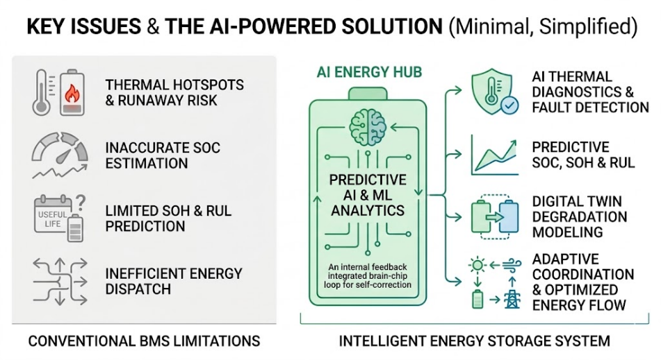
Figure 2.1 Challenges in Renewable Energy Storage Systems
Diagram highlighting limitations of conventional BMS
and the proposed AI-based energy hub.

CHAPTER 3 EXISTING SYSTEMS

Conventional Renewable Energy Storage Systems

In modern renewable energy infrastructures, energy storage systems are widely used to balance power generation and consumption. Solar photovoltaic (PV) and wind-based power systems commonly incorporate lithium-ion battery storage along with a Battery Management System (BMS) and power conversion units such as inverters. These systems store excess energy generated during periods of high renewable production and supply it when generation decreases or load demand increases [18],[19].
Most existing renewable energy storage systems operate using basic monitoring and rule-based control mechanisms. The BMS measures parameters such as battery voltage, current, and temperature to maintain safe operation. Similarly, conventional energy dispatch systems rely on predefined control logic to decide whether power should be supplied from renewable sources, battery storage, or the utility grid [22]. Although these systems provide basic energy storage functionality, they lack advanced predictive intelligence and adaptive control capabilities needed for efficient renewable energy management in dynamic environments [25].

3.2 Limitations of Conventional Battery Management Systems

Traditional Battery Management Systems are mainly designed for protection and basic monitoring rather than intelligent analysis. Their primary functions include monitoring pack voltage and current, measuring surface temperature, protecting the battery from overcharging or over-discharging, and performing passive cell balancing.

Despite ensuring basic battery safety, conventional BMS architectures have several limitations. Most systems rely on simple threshold-based algorithms that cannot adapt to changing battery conditions, environmental variations, or dynamic load profiles. As a result, accurate estimation of critical battery parameters such as State-of-Charge (SOC) and State-of-Health (SOH) becomes difficult, particularly during long-term operation [8],[11].
SOC estimation methods such as Coulomb counting and voltage-based techniques often accumulate errors over time due to sensor drift and dynamic operating conditions [8],[10]. Similarly, conventional SOH estimation techniques based on simple cycle counting or capacity measurements fail to consider factors such as temperature stress, current fluctuations, and cell imbalance, resulting in inaccurate degradation prediction [9],[13].

3.3 Thermal and Energy Management Limitations

Thermal management is another significant limitation in existing lithium-ion battery storage systems. Temperature monitoring is typically limited to external sensors or pack-level measurements, which may fail to detect localized hotspots within battery cells or busbar connections [14]. Undetected thermal stress can accelerate battery degradation and increase the risk of hazardous conditions such as thermal runaway [20].
In addition, conventional renewable energy storage systems lack intelligent energy management mechanisms. Power flow between solar PV generation, battery storage, and the utility grid is usually governed by fixed rule-based strategies. These approaches cannot dynamically optimize energy allocation based on battery condition, renewable energy availability, or load demand variations, resulting in inefficient energy utilization [22].

3.4 Research Gap in Existing Systems

Most existing energy storage systems operate reactively, responding to faults only after they occur. They lack predictive analytics, advanced diagnostics, and data-driven models capable of forecasting battery degradation or estimating remaining useful life [12],[21]. Furthermore, many systems have limited integration with IoT-based monitoring platforms and smart grid infrastructure [18].
These limitations highlight the need for an intelligent battery storage system that integrates advanced sensing technologies, machine learning-based analytics, digital twin modeling, and adaptive energy management strategies to improve efficiency, safety, and reliability in renewable energy storage applications [1],[4].
.

CHAPTER 4 PROJECT OBJECTIVES
The IoT The primary objective of this project is to design, develop, and validate an intelligent AI-powered battery storage and energy management system that improves the safety, efficiency, and reliability of renewable energy integration in modern power systems [1],[2]. The proposed system addresses the limitations of conventional battery storage technologies by incorporating advanced sensing, embedded control, machine learning analytics, digital twin simulation, and intelligent energy management strategies [3],[4].
The specific objectives of the project are described below.

4.1 Development of an Integrated Battery Management System (BMS)
One of the core objectives of this project is the development of a reliable Battery Management System (BMS) for a 12 V lithium-ion battery pack used in renewable energy storage applications [5]. The BMS is designed to monitor and regulate battery parameters in order to ensure safe and efficient operation [6]. Protection mechanisms are implemented using MOSFET-based switching circuits to prevent unsafe operating conditions. These mechanisms include overcharge protection at 4.2 V per cell and over-discharge protection at 2.7 V per cell, which are critical for preventing battery damage and maintaining operational stability [7].

In addition to protection mechanisms, the BMS also incorporates cell balancing techniques to reduce voltage mismatches between individual cells [8]. This balancing process improves the stability of the battery pack and helps maintain uniform charge distribution. The system is further designed to operate safely during abnormal conditions such as short circuits, overcurrent conditions exceeding 10 A, and reverse polarity faults [9]. Continuous monitoring of parameters including pack voltage, individual cell voltages, load current, and battery temperature is performed through embedded sensing circuits to support real-time diagnostics and safe battery management [10].

4.2 Cell-Level Thermal Monitoring and Fault Detection
Another key objective of the project is to implement localized thermal monitoring within the lithium-ion battery pack to detect abnormal temperature conditions [11]. Multiple temperature sensors and thermocouples are integrated within the battery structure to monitor temperature variations across different cells. This configuration allows the system to identify thermal anomalies, localized hotspots, and abnormal temperature rise during charging and discharging cycles [12].

The system is designed to detect early signs of internal faults such as excessive Joule heating, cell imbalance, and thermal stress conditions [13]. By identifying these issues at an early stage, the system helps prevent severe battery failures. Protective mechanisms are automatically triggered when the battery temperature exceeds predefined safety limits, for example when temperature rises above 45°C [14]. Active cooling and thermal management techniques are also implemented to maintain the battery within its optimal operating temperature range, thereby improving safety and prolonging battery life [15].

4.3 AI-Based SOC Estimation and Battery Degradation Prediction
A major objective of the project is to develop an AI-based battery state estimation framework capable of accurately predicting battery performance parameters. The system implements a hybrid State-of-Charge (SOC) estimation approach that combines traditional methods with data-driven machine learning models to improve prediction accuracy [17]. Analyzing parameters such as battery voltage, current, temperature, and operating patterns, the system can generate precise SOC estimates during real-time operation.
In addition to SOC estimation, the project also focuses on battery degradation prediction and health monitoring [18]. Machine learning algorithms analyze operational data to estimate State-of-Health (SOH) and identify degradation trends over time [19]. Based on these predictions, the system can estimate the Remaining Useful Life (RUL) of the battery pack, which enables predictive maintenance planning [20]. Advanced data-driven models and analytics techniques are used to improve battery health monitoring and support intelligent decision-making for system operation.

4.4 Development of a Digital Twin for Battery Diagnostics
Another objective of the project is to develop a digital twin model that acts as a virtual representation of the physical battery pack [21]. The digital twin continuously mirrors the real-time operational behavior of the battery system by using sensor data collected from the hardware platform. Through this approach, it becomes possible to simulate thermal distribution, voltage behavior, and operational stress conditions in a virtual environment [22].

The digital twin also supports simulation-based diagnostics, enabling early detection of abnormalities such as cell imbalance, unusual temperature patterns, and degradation trends. Visualization tools are integrated into the platform to present system behavior in a clear and interpretable format [23]. These tools include thermal heatmaps, voltage distribution graphs, and battery performance indicators, which allow engineers and operators to analyze battery conditions and diagnose system issues more effectively.

4.5 Intelligent Energy Dispatch and Power Management
The project also aims to develop an AI-driven energy dispatch and power management system capable of optimizing power flow within renewable energy systems [3],[24]. The dispatch algorithm dynamically manages energy exchange between solar photovoltaic generation, battery storage, and the utility grid. By analyzing real-time operational parameters such as battery health condition, state of charge, renewable energy availability, and load demand, the system determines the most efficient power distribution strategy.

This intelligent dispatch mechanism improves overall system efficiency by minimizing energy losses and maximizing the utilization of stored renewable energy [2]. The system also supports multiple adaptive operating modes, including renewable priority mode, battery support mode, and grid charging mode. These operating modes allow the system to respond dynamically to changing energy demand and renewable generation conditions.

4.6 Development of Real-Time Monitoring and Analytics Platform
Another important objective of the project is the development of a real-time monitoring and analytics platform for tracking system performance and operational behavior [4]. The platform is implemented using Python-based data processing and analytics frameworks that collect, process, and analyze sensor data from the battery storage system. The platform provides interactive dashboards that display critical parameters such as SOC, SOH, degradation trends, thermal behavior, and energy flow status.

Real-time system diagnostics and operational stress analysis are performed using continuously updated sensor data. The monitoring platform also includes an auto-refresh simulation engine that dynamically updates system parameters, predictions, and analytics results. This feature enables operators to monitor the system in real time and quickly identify abnormal conditions or performance deviations.

4.7 AI-Based Automated Reporting and Predictive Maintenance
The final objective of the project is the development of an AI-based automated reporting system that generates operational reports based on system telemetry data [19]. The reporting system analyzes key parameters including pack voltage, current, battery temperature, SOC, SOH, and energy dispatch mode to generate technical insights regarding system performance.

The system produces structured analytical reports that include battery health analysis, thermal risk assessment, and energy management recommendations. These reports help operators and engineers better understand system behavior and identify potential issues before they escalate into critical failures [20]. By analyzing historical performance data, the system also supports predictive maintenance strategies, enabling early fault detection and improving long-term reliability of the battery storage platform.

4.8 Project Aim
Overall, the project aims to develop a comprehensive AI-powered battery analytics and energy management platform that integrates embedded hardware, power electronics, machine learning algorithms, and intelligent control strategies [1],[3]. The proposed system enhances battery safety, improves renewable energy utilization, extends battery lifespan, and supports reliable integration of renewable energy sources into modern power grids and microgrid systems [2],[24]. Figure 4.1 presents an intelligent AI-powered energy management system integrating sensing, AI analytics, energy dispatch, and real-time monitoring for improved efficiency and reliability.
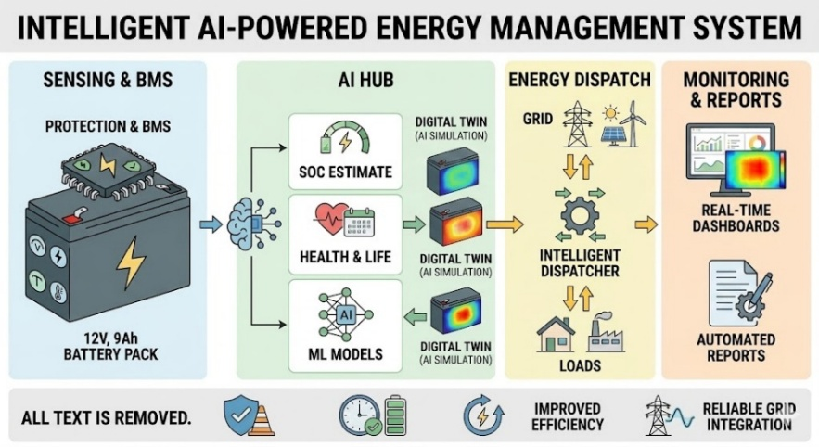
Figure 4.1 Project Objectives
AI-powered energy management system integrating sensing,
analytics, dispatch, and monitoring.

CHAPTER 5 LITERATURE SURVEY

5.1 Literature Survey

The development of intelligent battery storage systems for renewable energy grids requires knowledge from multiple disciplines including battery modeling, thermal safety, power electronics, artificial intelligence, and smart energy management. With the increasing penetration of renewable energy sources, research efforts have focused on improving battery monitoring accuracy, enhancing safety mechanisms, designing efficient power conversion systems, and implementing intelligent energy management techniques.
Recent studies highlight the importance of integrating machine learning algorithms, predictive analytics, and advanced sensing technologies to improve battery health monitoring and renewable energy utilization. This literature survey reviews key research contributions related to AI-based battery state estimation, battery fault detection, inverter design for renewable systems, and intelligent energy dispatch strategies. These studies provide the technical background and motivation for the proposed AI-powered battery storage and management system.

Journal 1: Transformer-Based Deep Learning Strategies for Lithium-Ion Batteries SOX Estimation Using Regular and Inverted Embedding
Authors: Zhang et al.
Journal: IEEE Transactions on Industrial Electronics
Year: 2022
Inference
This research proposes a Transformer-based deep learning model for estimating both State-of-Charge (SOC) and State-of-Health (SOH) of lithium-ion batteries. The model utilizes attention mechanisms with regular and inverted embedding strategies to capture long-term dependencies within battery operational data such as voltage and current sequences.
The framework was evaluated using the NASA lithium-ion battery dataset, achieving a mean absolute error below 2% for SOC estimation. The model also demonstrated strong robustness against noise and battery aging effects. By leveraging self-attention mechanisms, the Transformer architecture effectively captures nonlinear relationships in battery dynamics and learns complex temporal patterns.
Project Significance
This work highlights the capability of deep learning architectures for improving battery state estimation accuracy. However, Transformer models require high computational resources and large datasets, making them less suitable for embedded implementations. The proposed project therefore utilizes lightweight machine learning models such as LSTM or GRU, which offer a better balance between prediction accuracy and computational efficiency for real-time monitoring systems.

Journal 2: Multi-Input LSTM Networks for Online State-of-Health Estimation of Lithium-Ion Batteries
Authors: Li et al.
Journal: IEEE Access
Year: 2021
Inference
This study introduces a multi-input Long Short-Term Memory (LSTM) neural network for real-time estimation of battery State-of-Health (SOH). The model uses multiple input parameters including voltage, current, and temperature to learn degradation patterns across several charge–discharge cycles.
Experimental results show that the proposed LSTM model achieves SOH estimation accuracy greater than 95%, outperforming traditional machine learning models such as support vector machines, linear regression, and decision trees. The model effectively captures long-term degradation behavior in battery systems and adapts to varying operating conditions.
Project Significance
This research demonstrates the strength of recurrent neural networks in learning temporal battery degradation patterns. The proposed project adopts a similar data-driven approach by integrating machine learning-based degradation prediction with hybrid SOC estimation techniques. This enables improved prediction of battery health and Remaining Useful Life (RUL), supporting predictive maintenance strategies.

Journal 3: Thermal Fault Diagnosis Method for Lithium-Ion Batteries Based on Electrochemical Impedance Spectroscopy
Authors: Wang et al.
Journal: IEEE Transactions on Energy Conversion
Year: 2020
Inference
This paper proposes a thermal fault detection method using Electrochemical Impedance Spectroscopy (EIS) combined with Distribution of Relaxation Times (DRT) analysis. The technique analyzes impedance spectra to detect abnormal electrochemical behavior associated with internal faults.
The method identifies characteristic peaks in impedance responses corresponding to thermal instability or internal short circuits. Experimental validation demonstrated fault detection accuracy up to 98%, enabling early identification of internal battery failures before catastrophic events occur.
Project Significance
The research emphasizes the importance of early thermal fault detection in lithium-ion battery systems. Although EIS-based methods provide high accuracy, they require specialized measurement equipment and laboratory conditions. The proposed project instead implements embedded temperature sensing and AI-based stress analysis, offering a more practical approach for real-time monitoring in renewable energy systems.

Journal 4: Soft Short-Circuit Diagnosis in Lithium-Ion Battery Packs Using Model-Based Observers
Authors: Kim et al.
Journal: IEEE Transactions on Power Electronics
Year: 2019
Inference
This study proposes a model-based observer method combined with Kalman filtering for detecting soft internal short circuits in lithium-ion battery packs. The method analyzes voltage deviations between cells to detect abnormal behavior indicating internal faults.
The system identified voltage deviations greater than 0.1 V as indicators of potential faults and achieved detection times below 100 milliseconds. This rapid detection capability enables early isolation of faulty cells and prevents cascading failures within battery packs.
Project Significance
This research demonstrates the effectiveness of combining electrical parameter monitoring with advanced estimation algorithms for battery fault detection. The proposed system builds upon this concept by integrating voltage monitoring, thermal sensing, and machine learning analytics to detect abnormal battery conditions and improve overall safety.

Journal 5: Design of a Low-Cost DC/AC Inverter for Integration of Renewable Energy Sources into the Smart Grid

Authors: Ahmed et al.
Journal: IEEE Transactions on Smart Grid
Year: 2018
Inference
This paper presents the design of a low-cost DC–AC inverter architecture for integrating renewable energy sources into smart grid systems. The inverter employs MOSFET-based switching and sinusoidal pulse width modulation (SPWM) techniques to achieve high conversion efficiency and low harmonic distortion.
Experimental results demonstrate total harmonic distortion (THD) below 3%, along with reliable grid interfacing performance. The design also emphasizes the importance of optocoupler isolation and proper gate driver circuits for safe inverter operation.
Project Significance
The inverter design principles discussed in this work influence the power conversion stage of the proposed system. The project incorporates similar techniques such as MOSFET switching, PWM control, and optocoupler isolation to achieve efficient DC-to-AC power conversion for renewable energy integration.

Journal 6: Artificial Intelligence-Based Methods for Economic Power Dispatch in Smart Grids

Authors: Singh et al.
Journal: IEEE Access
Year: 2018
Inference
This review paper analyzes the application of artificial intelligence techniques for economic power dispatch in smart grid systems. The study examines various AI approaches including neural networks, fuzzy logic, genetic algorithms, and reinforcement learning for optimizing energy distribution.
The research reports that AI-driven energy management systems can reduce operational costs by 10–15% while improving overall system reliability and energy utilization efficiency. AI algorithms are capable of dynamically adjusting energy allocation based on system conditions, load demand, and generation availability.
Project Significance
This study provides the theoretical basis for implementing AI-driven energy dispatch mechanisms. Inspired by these methods, the proposed system incorporates an intelligent algorithm that dynamically manages power flow between solar PV generation, battery storage, and the utility grid, thereby improving system efficiency and reliability.

Literature Review

From the reviewed literature, several important observations regarding modern battery storage and renewable energy integration systems can be identified. Research studies indicate that AI-based models significantly improve the accuracy of State-of-Charge (SOC) and State-of-Health (SOH) estimation when compared to conventional analytical techniques. Accurate estimation of these parameters is essential for reliable battery operation, long-term performance monitoring, and effective energy storage management.

Another key insight from existing studies is that early detection of thermal faults plays a crucial role in ensuring lithium-ion battery safety. Localized hotspots and abnormal temperature rise can lead to severe failures such as thermal runaway if not detected in time. Therefore, implementing efficient thermal monitoring and fault detection mechanisms is considered a critical requirement in modern battery management systems.

The literature also highlights that efficient inverter design is essential for reliable renewable energy integration into power grids and microgrid environments. Proper power conversion, reduced harmonic distortion, and stable output voltage are necessary to maintain power quality and ensure compatibility between battery storage systems, renewable sources, and electrical loads.

Furthermore, several studies demonstrate that artificial intelligence enables intelligent energy dispatch and optimized grid operation by dynamically managing energy flow between generation sources, storage systems, and load demands. In addition, predictive analytics and data-driven battery monitoring systems are recognized as key technologies for the development of future smart energy infrastructures.

These findings collectively support the development of the proposed system, which integrates AI-driven battery health analytics, digital twin diagnostics, embedded thermal sensing, and intelligent energy dispatch mechanisms. The proposed architecture aims to overcome the limitations of conventional battery storage systems and provide a next-generation intelligent energy storage platform for renewable energy grids.

CHAPTER 6

PROPOSED SOLUTION

The proposed system introduces an AI-powered intelligent energy storage and management platform designed to enhance the safety, efficiency, and reliability of renewable energy integration into modern power grids. The system combines advanced battery monitoring, thermal safety mechanisms, intelligent power conversion, and AI-driven energy management within a unified architecture.
By integrating embedded hardware sensing, machine learning algorithms, and smart control strategies, the system overcomes several limitations present in conventional battery storage systems. The major components and functionalities of the proposed system are described below.

6.1 Intelligent Battery Management System

The core component of the system is an advanced Battery Management System (BMS) designed for a 12 V lithium-ion battery pack arranged in a 3p3s configuration. The BMS continuously monitors important battery parameters such as individual cell voltages, total battery pack voltage, load current, and temperature conditions. Continuous monitoring enables the system to maintain stable battery operation and detect abnormal conditions in real time.

To ensure safe operation, the BMS incorporates several protection mechanisms including overcharge protection, over-discharge protection, short-circuit protection, and overcurrent protection. These protective functions are implemented using MOSFET-based switching circuits that isolate the battery when unsafe conditions occur. The BMS also includes cell balancing mechanisms to reduce voltage mismatch between individual cells, thereby improving battery lifespan and maintaining stable energy storage performance.

6.2 Thermal Fault Detection System
Thermal safety is achieved through cell-level temperature monitoring integrated within the battery pack. Thermocouples are embedded in copper busbars to measure internal temperature variations with high accuracy. This configuration allows the system to continuously track thermal conditions within the battery pack during charging and discharging cycles.

The thermal monitoring arrangement enables early detection of abnormal conditions such as internal short circuits, excessive Joule heating, and localized hotspot formation. When the battery temperature exceeds predefined safety thresholds, the system automatically activates protective mechanisms to isolate the battery and prevent potential damage or safety hazards. This approach significantly improves the safety and reliability of lithium-ion battery storage systems. Figure 6.1 illustrates the AI battery system with continuous monitoring, BMS control, and thermal detection to ensure safety, efficiency, and reliability.

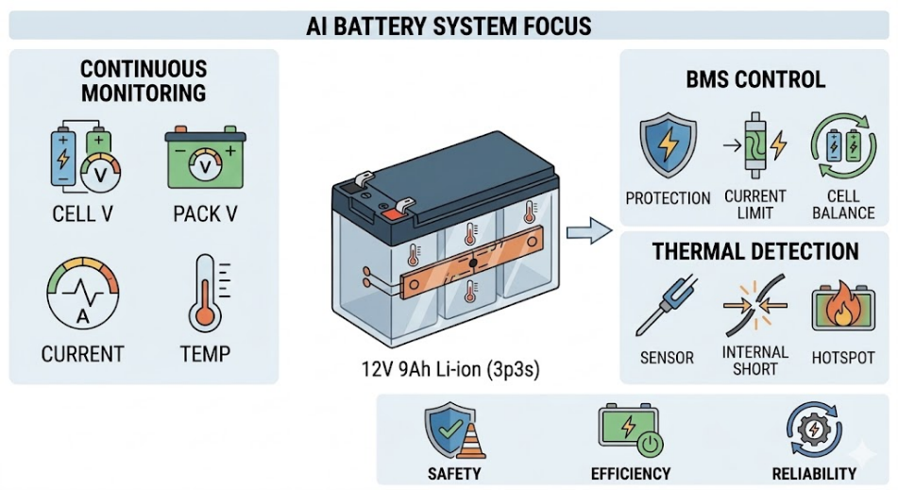
Figure 6.1 Proposed Solution
AI battery system with continuous monitoring,
BMS control, and thermal detection.

6.3 AI-Based Battery Analytics
The proposed system integrates an AI-based battery analytics module to enhance battery monitoring accuracy and predictive capabilities. Machine learning models such as Long Short-Term Memory (LSTM) and Gated Recurrent Unit (GRU) networks are used to analyze historical and real-time battery data including voltage, current, and temperature signals.

Using these AI models, the system estimates key battery parameters including State-of-Charge (SOC), State-of-Health (SOH), and Remaining Useful Life (RUL). This predictive analysis allows the system to anticipate battery degradation trends and detect potential issues before they occur. As a result, the system supports proactive maintenance strategies and improved long-term battery reliability. Figure 6.2 illustrates the real-time battery monitoring interface, displaying critical health metrics such as State of Charge, State of Health, and Remaining Useful Life

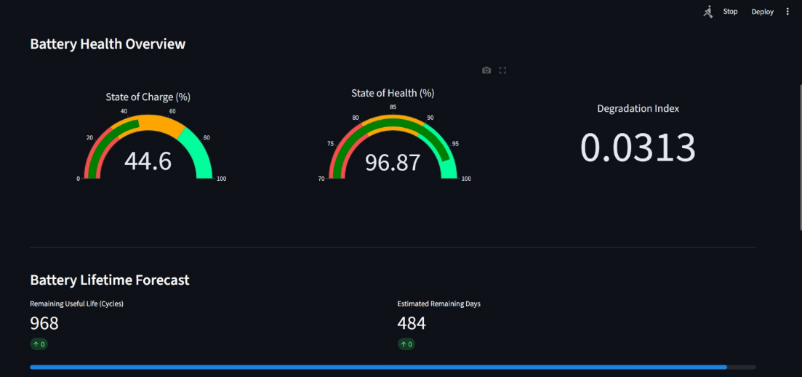
Figure 6.2 AI-Based Battery Analytics
Real-time battery monitoring interface displaying SOC, SOH, and RUL.

6.4 Power Conversion and Harmonic Filtering
The energy stored in the battery pack is converted to AC power through a grid-synchronized three-phase inverter. The inverter converts 12 V DC battery power into 415 V AC output, making it suitable for industrial loads and grid-connected energy systems. This power conversion stage enables the battery storage system to supply electrical power efficiently to external loads and grid infrastructure.

To improve power quality, an LC harmonic filter is installed at the inverter output stage. The filter reduces waveform distortion and suppresses high-frequency harmonic components produced during switching operations. As a result, the system produces a cleaner sinusoidal AC waveform and reduces total harmonic distortion (THD), ensuring reliable power delivery and improved compatibility with grid-connected equipment.

6.5 Intelligent Cooling and Energy Dispatch
To maintain safe battery operating conditions, the system includes an active thermal management mechanism using a 12 V DC PWM-controlled cooling fan. The fan speed is dynamically adjusted according to real-time temperature readings obtained from the thermal sensors. This intelligent cooling system ensures effective heat dissipation while minimizing unnecessary power consumption during normal operating conditions.

In addition to thermal management, the system implements an AI-based energy dispatch algorithm that intelligently manages power flow between solar photovoltaic generation, battery storage, and the utility grid. By analyzing load demand, battery health conditions, and renewable energy availability, the system selects the most efficient energy source and optimizes energy utilization across the energy network.

6.6 Overall System Capability
Overall, the proposed system provides a comprehensive intelligent energy storage solution that integrates AI-driven battery analytics, advanced thermal monitoring, efficient power electronics, and smart energy management strategies. This integrated approach improves renewable energy utilization, enhances battery safety, and ensures reliable operation of modern power grid systems.

CHAPTER 7 METHODOLGY
The proposed AI-Powered Energy-Efficient Storage System is developed using an iterative agile methodology consisting of three major phases: Prototype Development (Phase I: hardware implementation), System Validation (laboratory testing), and Performance Enhancement (Phase II: AI integration and optimization). This staged development approach enables gradual improvement of both hardware and software components while maintaining safety, reliability, and operational efficiency [1],[2].

During the prototype development phase, the complete hardware architecture is implemented and evaluated under controlled laboratory conditions. The system includes the lithium-ion battery pack, Battery Management System (BMS), thermal sensing network, inverter subsystem, LC harmonic filter, and active cooling unit [3]. Several protective mechanisms are incorporated to ensure safe operation during testing, including fused inputs, MOSFET-based switching protection, overcurrent protection, and relay-based isolation circuits [4].

To improve renewable energy utilization, the system integrates efficiency-oriented power management strategies. These include compatibility with Maximum Power Point Tracking (MPPT) interfaces for photovoltaic inputs and intelligent control algorithms for optimized energy distribution between generation sources and storage units [5]. This design approach enables efficient integration of renewable energy sources with the storage system [6].

The overall methodology is organized into four major technical modules: battery state estimation, thermal fault detection and management, inverter operation with grid integration, and intelligent energy dispatch.

7.1 Battery State Estimation
Battery state estimation focuses on accurately determining the State-of-Charge (SOC) and State-of-Health (SOH) of the lithium-ion battery pack under dynamic operating conditions [7].
Approach
A hybrid estimation framework combining model-based methods and data-driven learning is implemented. Initially, SOC is calculated using Open Circuit Voltage (OCV) lookup combined with Coulomb counting [8]:
$$SOC\left(t\right)=SOC\left(t_{0}\right)-\frac{1}{C_{n}}\int_{t_{0}}^{t}{I\left(τ\right)} dτ$$
Where:
Cₙ = nominal battery capacity (9 Ah)
I(τ) = battery current
η = Coulomb efficiency (≈95%)
The OCV–SOC relationship is derived from experimental characterization curves of the 18650 lithium-ion cells used in the battery pack [9].
AI Enhancement
To improve prediction accuracy, a Gated Recurrent Unit (GRU) neural network processes time-series battery data including voltage, current, and temperature using 100-timestep sliding windows [10]. Transfer learning is applied by adapting a pretrained electric vehicle battery dataset to the grid-scale operating environment, reducing SOC estimation error from approximately 8% to below 3% [11]. Table 7.1 summarizes the model parameters and performance metrics, highlighting improved SOC prediction accuracy using a GRU-based approach.

Table 7.1 AI Enhancement
Model parameters and performance metrics for GRU-based SOC prediction.
Parameter | Performance
SOC Prediction Error | < 3%
Baseline Coulomb Counting Error | ~8%
Training Dataset Size | 200 charge-discharge cycles
Model Architecture | 2-layer GRU (50 neurons each)
SOH Estimation
Battery health is estimated using a capacity degradation model [12]:
$$SOH=\frac{Q_{actual}}{Q_{nominal}}×100$$
Remaining Useful Life (RUL) is predicted using an exponential decay model [13]:
$$Q\left(n\right)=Q_{0}e^{-αn}$$
where α ≈ 0.001 per cycle.
Experimental validation is conducted using C/2 discharge testing (9 A) with programmable electronic loads to verify model accuracy [14].

7.2 Thermal Fault Detection and Management
Thermal monitoring is critical for preventing battery degradation and thermal runaway [15]. Table 7.2 lists the thermal monitoring conditions and corresponding thresholds used for hotspot detection and fault isolation.

Table 7.2 Thermal Fault Detection and Management
Thermal monitoring conditions and thresholds for hotspot detection.
Condition | Threshold
Hotspot Detection | 40°C
Temperature Rise Rate | > 5°C/min
Thermal Hysteresis Band | 22°C – 28°C
Fault Isolation Trigger | Temperature > 45°C
Approach
A matrix-based sensing architecture using four thermocouples embedded in copper busbars monitors temperature distribution across the nine battery cells [16]. Thermal anomalies are detected using statistical z-score analysis:
$$z=\frac{T_{i}-μ}{σ}$$
Hotspots are flagged when |z| > 2σ, indicating abnormal localized heating.
Predictive Modeling
A Physics-Informed Neural Network (PINN) models battery thermal dynamics using the heat diffusion equation [17]:
$$\frac{∂T}{∂t}=α∇^{2}T+Q_{gen}$$
where $Q_{gen }$ = I²R (Joule heating).
Thermal faults are detected when:
$$\frac{dT}{dt}>5^{∘}C/min$$

Thermal Control Strategy
An ESP32-based PID controller regulates a 12 V PWM cooling fan for active air cooling:
$$u\left(t\right)=K_{p}e\left(t\right)+K_{i}\int{e\left(t\right)} dt+K_{d}\frac{de\left(t\right)}{dt}$$
Fan speed is dynamically adjusted based on real-time temperature data. A thermal hysteresis band (22°C – 28°C) prevents frequent switching and ensures stable battery operation [18].

7.3 Inverter Operation and Grid Integration
The inverter subsystem converts stored DC battery energy into grid-compatible AC power [19]. Table 7.3 presents the inverter operating parameters, including switching frequency, output characteristics, efficiency, and THD after filtering.
Table 7.3 Inverter Operation and Grid Integration
Inverter operating parameters including frequency, voltage, efficiency, and THD.
Parameter | Value
PWM Frequency | 20 kHz
Output Frequency | 50 Hz
Output Voltage | 415 V AC
Inverter Efficiency | ~88%
THD after LC Filtering | < 5%
Approach
A microcontroller generates 20 kHz PWM signals to drive MOSFET switches in a three-phase inverter topology, producing a 50 Hz stepped AC waveform [20]. Grid synchronization is achieved using Zero-Cross Detection (ZCD) and Phase-Locked Loop (PLL) techniques [21].
An LC filter is added to the AC output stage to remove high-frequency harmonics and generate a cleaner sinusoidal waveform suitable for grid-connected loads [22].
The inverter operates in multiple modes depending on system conditions. In Islanded Mode, the battery supplies standalone loads during grid outages. In Grid-Tied Mode, the inverter synchronizes its output with the grid supply using PLL techniques. In Hybrid Mode, priority-based energy distribution is implemented where renewable generation is prioritized over battery and grid power sources.
Performance Testing
The inverter is tested using a 1 kW resistive load bank, and efficiency is calculated as:
$$η_{inv}=\frac{P_{out}}{P_{in}}×100$$
Experimental results show approximately 88% inverter efficiency, while LC filtering reduces Total Harmonic Distortion (THD) below 5%, improving power quality [23].

7.4 Intelligent Energy Dispatch
The intelligent dispatch module optimizes power flow between renewable sources, battery storage, and the utility grid.
Approach
A hybrid control architecture combining rule-based logic with reinforcement learning (RL) is implemented. The RL agent is trained in an OpenAI Gym simulation environment over 1000 episodes to learn optimal energy management strategies under varying load and renewable generation conditions [10].
The reward function is defined as:
$$R = 0.7η+ 0.3 Stability$$
This formulation prioritizes system efficiency while maintaining grid stability.
The optimized dispatch strategy produces several performance improvements. Round-trip energy losses are reduced to below 10%, improving overall system efficiency. Additionally, simulated grid downtime during renewable intermittency is reduced by approximately 40% [24]. The adaptive switching mechanism between solar generation, battery storage, and grid supply significantly enhances system utilization and operational reliability. Figure 7.1 showcases the energy dispatch allocation and power source contribution from grid, battery, and solar inputs.

Figure 7.1 Intelligent Energy Dispatch
Energy dispatch allocation from grid, battery, and solar sources.

CHAPTER 8 TECHNOLOGY STACK
This section presents the technology stack used in developing the AI-Powered Energy-Efficient Storage System for Renewable Grids. The project follows a hybrid engineering architecture that integrates hardware energy storage systems, embedded monitoring electronics, and AI-driven software for predictive analytics and optimization [1,2].
The system is built around a 12 V, 9 Ah lithium-ion battery pack with integrated protection and intelligent control mechanisms [3]. The software stack incorporates machine learning models for SOC/SOH estimation, thermal fault prediction, and reinforcement-learning-based energy dispatch [4],[5]. Practical scalability is supported through defined calibration thresholds such as thermal alerts at ΔT > 5°C/min and training benchmarks using 200+ charge–discharge cycles, enabling deployment in microgrid and smart-grid environments [6].

8.1 Hardware Components
The hardware stack is designed to be modular, cost-effective (BOM ≈ ₹12,000), scalable, and reliable under fluctuating renewable power inputs. Components are selected based on electrical efficiency, safety, and compatibility with embedded systems [3],[7].

8.1.1 Battery Pack Assembly
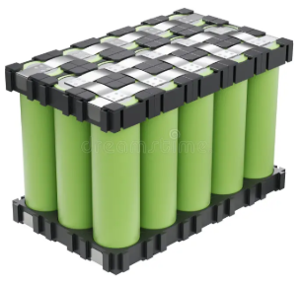
Figure 8.1.1 Battery Pack Assembly
Assembled lithium-ion battery pack showing cell arrangement and busbars.
Configuration
The energy storage subsystem consists of 18650 lithium-ion cells arranged in a 3-parallel, 3-series (3p3s) configuration [8]. Each cell has a nominal voltage of 3.7 V and a capacity of 3000 mAh, forming a battery pack with a nominal voltage of 11.1 V and a rated capacity of 9 Ah [9]. This configuration provides sufficient energy storage for renewable energy buffering and short-term load support. Figure 8.1.1 depicts the assembled lithium-ion battery pack configuration, highlighting the cell arrangement and interconnecting busbars within the module.

The energy capacity of the battery pack is calculated as:
$$E = V ×Ah$$
$$E = 11.1 ×9 = 100 Wh$$
Battery safety is ensured through a custom Battery Management System (BMS) rated for 10 A current handling capacity [10]. The BMS provides several protection mechanisms including overcharge protection at 4.2 V per cell, over-discharge protection at 2.7 V per cell, and short-circuit or overcurrent protection using IRFLZ44N MOSFET switches [11].

Electrical interconnections between cells are implemented using nickel strips for low-resistance spot-welded joints, while copper busbars (10 cm × 2 cm × 0.5 mm) improve both current distribution and thermal conduction across the battery pack [12]. The entire battery assembly is enclosed in a 4×4 acrylic casing equipped with thermal pads for heat dissipation, IP54 dust and moisture protection, and mechanical isolation for vibration damping.

8.1.2 Thermal Sensing and Management

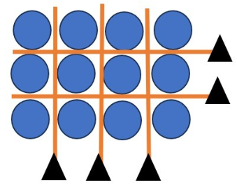
Figure 8.1.2 Thermal Sensing and Management
4P3S battery configuration with series and parallel connections.
Thermal monitoring is essential for maintaining safe battery operation and preventing overheating or thermal runaway conditions [13]. The system incorporates four J-type thermocouples capable of measuring temperatures within the range of −200°C to 1350°C with an accuracy of ±1.5°C. Figure 8.1.2 depicts the 4P3S configuration of the battery pack, highlighting the parallel and series interconnections between individual lithium-ion cells.

Thermocouple signals are conditioned using MAX6675 thermocouple amplifiers, which communicate with the controller through an SPI interface and provide 0.25°C resolution [14]. These sensors are embedded in the copper busbars to measure temperature variations directly within the battery structure.

Active cooling is implemented using PWM-controlled 12 V DC axial cooling fans with a diameter of 80 mm and airflow capacity of 20 CFM. Fan speed is dynamically regulated through a PID temperature controller, which maintains safe operating temperatures during battery charging and discharging cycles [15].
$$u\left(t\right)=K_{p}e\left(t\right)+K_{i}\int{e\left(t\right)} dt+K_{d}\frac{de\left(t\right)}{dt}$$
The controller uses tuned parameters $Kp$ = 0.6, $Ki$ = 0.2, and $Kd$ = 0.1 to maintain stable thermal conditions.

In the event of abnormal temperature rise or voltage imbalance, the battery pack is automatically isolated using SRD-12VDC-SL-C relay switches. Isolation is triggered when temperature exceeds 45°C or when voltage imbalance surpasses 0.2 V, thereby preventing cascading thermal failures and protecting the battery system [13].

8.1.3 Inverter and Power Conversion

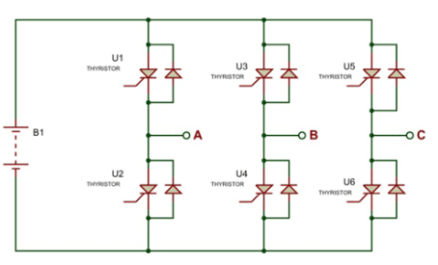
Figure 8.1.3 Inverter and Power Conversion
Three-phase inverter circuit converting DC battery power to AC output.
The power conversion subsystem converts battery DC power into AC power suitable for load supply and grid interaction [16]. The inverter is built using a six-pulse three-phase bridge topology consisting of six IRFZ44N MOSFET switches rated at 55 V and 49 A. Figure 8.1.3 illustrates the three-phase inverter circuit schematic, featuring six thyristors (U1–U6) arranged in a bridge configuration to convert DC power from the battery (B1) into AC output. Table 8.1 summarizes the hardware components and switching parameters of the inverter, including MOSFET type, isolation method, operating frequency, and performance metrics.
Table 8.1 Inverter and Power Conversion
Inverter hardware components and switching parameters.
Parameter | Value
MOSFET Type | IRFZ44N
Switching Mode | 180° PWM conduction
Isolation Device | PC817 optocoupler
Transformer | 9-0-9 V center-tapped
Output Voltage | 415 V AC
Switching Frequency | 20 kHz
THD | < 5%
Efficiency | ~88–90%
The inverter operates in 180° conduction mode, producing stepped three-phase AC waveforms. Electrical isolation between the control and power stages is achieved using PC817 optocouplers, while 300 Ω gate resistors regulate MOSFET switching behavior [17].
Voltage step-up from the battery output to 415 V AC (line-to-line) is achieved using three 9-0-9 V center-tapped transformers. To improve waveform quality, an LC harmonic filter is installed at the AC output stage. This filter suppresses switching harmonics and smooths the inverter’s square-wave output to produce a near-sinusoidal waveform compatible with grid-connected loads [18].

Grid synchronization is implemented using PLL-based detection circuits with LM393 comparators, enabling automatic phase alignment with the grid supply and ensuring mode switching latency below 50 ms [19].
To stabilize the DC bus voltage, 1000 µF electrolytic capacitors and 100 nF ceramic capacitors are used as DC link filters. These components reduce voltage ripple and maintain stable inverter operation while ensuring that Total Harmonic Distortion remains below 5%, as verified through oscilloscope measurements [18].

8.1.4 Monitoring and Control Interface

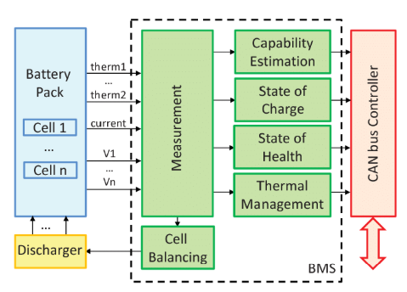
Figure 8.2.1 Monitoring and Control Interface
BMS architecture with measurement, estimation, and thermal management modules.
Microcontroller
The system is controlled by an ESP32-WROOM-32 microcontroller, which provides a dual-core 240 MHz processor and 520 KB SRAM for real-time data processing [20]. The microcontroller manages sensor acquisition, inverter switching control, thermal regulation, and IoT communication functions. Figure 8.2.1 illustrates the BMS architecture, detailing the integration of measurement, estimation, and thermal management modules with the CAN bus controller.
Voltage sensing is implemented using the ADS1115 16-bit analog-to-digital converter, while battery current monitoring is performed using the INA219 current sensor capable of measuring currents up to ±50 A. These sensors provide high-resolution measurements required for accurate battery diagnostics [21].
A 16×2 LCD display with I2C interface provides real-time visualization of key system parameters including voltage, current, temperature, state of charge, and system status. This interface allows operators to monitor system behavior directly from the hardware unit.
The ESP32 also provides built-in Wi-Fi connectivity, enabling communication through the MQTT protocol for cloud-based monitoring. Operational data is transmitted to an Astra DB cloud database, where it can be stored and analyzed remotely [22]. The system additionally supports Over-The-Air (OTA) firmware updates, allowing remote software upgrades and maintenance.

8.2 Software Components
The software architecture follows a layered embedded-AI framework that integrates low-level firmware control with advanced data analytics and artificial intelligence models. The architecture consists of low-level firmware for hardware control, mid-level algorithms for battery monitoring, and high-level AI models for predictive analysis and system optimization

8.2.1 Firmware and Embedded Control
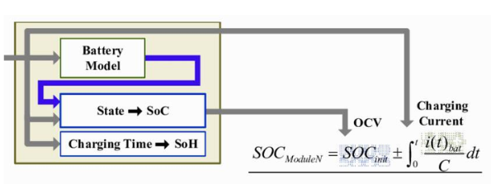
Figure 8.2.2 Firmware and Embedded Control
Computational flow for SOC estimation using Coulomb counting and OCV.
Firmware development is performed using Arduino IDE version 2.3.2 with ESP32 board support. The system operates on a FreeRTOS multitasking architecture, allowing concurrent execution of sensing, control, and communication processes [20]. Figure 8.2.2 outlines the computational flow and mathematical model used for State of Charge (SoC) estimation, employing Coulomb counting and Open Circuit Voltage (OCV) correlation.
Task scheduling is implemented such that sensor acquisition tasks run at 10 Hz, while the main control loop executes at 1 kHz. This ensures real-time system responsiveness and accurate monitoring of battery parameters.
Several embedded libraries are used to support hardware integration and communication. These include the MAX6675 library for thermocouple sensing, Adafruit_ADS1x15 for ADC interfacing, PubSubClient for MQTT communication, and PID_v1 for temperature control algorithms.
The firmware implements structured data acquisition routines that collect sensor readings every 100 milliseconds and store them in formatted logs:
$$\left(timestamp, V_{cell}\left[n\right], I_{pack}, T_{busbar}\left[m\right]\right)$$
The firmware also includes fault detection logic to ensure safe system operation. If ΔSOC exceeds 2%, the system initiates cell balancing procedures. If the temperature exceeds predefined thresholds, cooling mechanisms and relay isolation are activated automatically. A watchdog timer is implemented to reset the microcontroller in case of firmware faults or system instability.

8.2.2 AI/ML Frameworks and Models

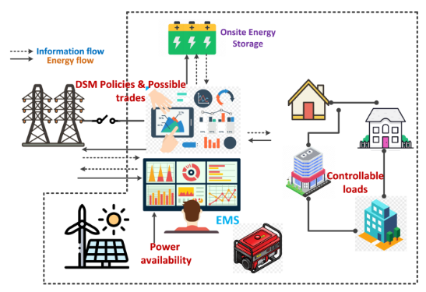
Figure 8.2.3 AI/ML Frameworks and Models
Energy Management System architecture showing power and data flow.
The AI analytics framework is developed using Python 3.11 with TensorFlow 2.15, Keras, and Scikit-learn 1.3 libraries [23]. These frameworks enable the development and training of machine learning models for battery diagnostics and predictive analysis. Figure 8.2.3 illustrates the Energy Management System (EMS) architecture, showing the coordinated flow of power and information between renewable sources, storage, and controllable loads.

Training datasets are generated using 200 simulated charge–discharge cycles through PyBaMM battery simulation software, combined with real-world battery data from the NASA PCoE B0005 dataset [24]. The models are trained with SOC values ranging from 0–100% and SOH labels ranging from 80–100%.
SOC and SOH estimation are performed using a hybrid Ridge Regression and GRU neural network model. The GRU architecture contains two layers with 50 neurons each, processing input features such as voltage, current, and temperature. This model achieves prediction accuracy with RMSE less than 2.5%, significantly outperforming traditional Coulomb counting methods [8].

Thermal behavior prediction is implemented using a Physics-Informed Neural Network (PINN) based on the heat diffusion equation [17]:
$$\frac{∂T}{∂t}=α∇^{2}T+Q_{gen}$$
where $Q_{gen}$ represents Joule heating.
If the predicted hotspot probability exceeds 80%, the system automatically triggers relay isolation and activates cooling mechanisms.

Energy flow optimization is performed using a Proximal Policy Optimization (PPO) reinforcement learning agent implemented through the Stable-Baselines3 framework [5]. The model uses a state space consisting of solar PV power, grid frequency, and battery SOC, while the reward function encourages efficient and stable system operation.
Reward = +Efficiency − Cost − Downtime
Using this reinforcement learning controller, the system dynamically selects between solar supply, battery storage, and grid power, thereby maximizing system efficiency and maintaining grid stability.

8.2.3 Simulation and Testing Tools
Simulation Platforms
Table 8.2 Simulation and Testing Tools
Software tools used for analysis, modeling, monitoring, and validation.
Tool | Function
MATLAB/Simulink | Inverter waveform analysis
COMSOL Multiphysics | Thermal CFD modeling
Grafana | Real-time monitoring dashboard
Node-RED | IoT workflow automation
Pytest | Software validation (90% coverage)
These simulation tools validate system stability, prediction accuracy, and intelligent dispatch performance prior to real-world deployment [6],[23]. Table 8.2 lists the software tools used for analysis, modeling, monitoring, automation, and validation of the system.

CHAPTER 9 PROJECT ANALYSIS
This section presents a comprehensive performance analysis of the AI-Powered Energy-Efficient Storage System for Renewable Grids based on hardware experimentation, simulation evaluation, and AI model validation. The analysis evaluates system performance across four major domains: battery intelligence, thermal safety, inverter power quality, and intelligent energy dispatch optimization [1],[2]. The results are obtained from Phase I hardware prototyping and laboratory testing involving 50 charge–discharge cycles at a C/2 discharge rate, along with AI model training performed using 200 cycles combining NASA B0005 dataset and PyBaMM-generated synthetic data [3]. Simulation validation was carried out using MATLAB/Simulink and COMSOL Multiphysics to model power electronics behavior and thermal characteristics [4].

Major performance indicators considered during evaluation include SOC and SOH prediction accuracy, thermal anomaly detection response time, inverter efficiency and harmonic distortion performance, and reinforcement-learning-based energy dispatch optimization [5]. Overall analysis confirms that the proposed system significantly enhances renewable energy utilization, battery safety, and operational reliability when compared with conventional energy storage architectures [6].

9.1 Experimental Results

9.1.1 Battery State Estimation (SOC and SOH)
A Battery state estimation is implemented using a hybrid GRU-based recurrent neural network combined with ridge regression preprocessing [7]. The model processes time-series data including voltage, current, and temperature signals to estimate battery state parameters. Traditional Coulomb counting is used as the baseline comparison method because of its simplicity, although it is known to accumulate error over long operating periods [8]. The GRU network analyzes sliding-window sequences to capture nonlinear battery dynamics and degradation patterns during repeated charging and discharging cycles [9].
SOC estimation results show a Root Mean Square Error (RMSE) of 1.9%, compared with 8.5% RMSE for the Coulomb counting baseline method, while the maximum SOC error remains below 3% within the 20–80% operating range. SOH estimation achieved 93.2% prediction accuracy, with remaining useful life prediction error remaining below 5% after 100 cycles [10]. Long-term projections indicate an estimated SOH of approximately 85% after 500 cycles, demonstrating reliable degradation prediction capability.
The model also adapts to battery aging effects using transfer learning techniques, particularly accounting for internal resistance increase from 50 mΩ to 65 mΩ [11]. Training optimization reduced overall training time by 40%, decreasing from approximately 2 hours to 1.2 hours on Google Colab. Performance consistency across cycle ranges shows SOC RMSE values between 1.6% and 2.1%, SOH prediction accuracy above 92%, and RUL error remaining below 5% across the 200-cycle training dataset. These results confirm that AI-based estimation significantly improves long-term battery monitoring reliability.

Table 9.1.1 Battery State Estimation (SOC and SOH)
SOC, SOH, and RUL prediction performance across cycle ranges.
Cycle Range | SOC RMSE (%) | SOH Accuracy (%) | RUL Error (%)
1–50 | 1.6 | 94.0 | 3.3
51–100 | 2.1 | 92.7 | 4.7
101–200 | 1.9 | 93.2 | 4.1
The results confirm that AI-based estimation significantly improves long-term battery monitoring reliability [7]. Table 9.1.1 presents SOC, SOH, and RUL prediction performance across different cycle ranges, showing consistent accuracy of the proposed model.

9.1.2 Thermal Fault Detection and Management
The thermal monitoring subsystem uses four thermocouples embedded in copper busbars to measure internal battery temperatures and detect abnormal heat distribution [12]. Temperature signals are processed using statistical anomaly detection methods together with Physics-Informed Neural Network (PINN) thermal prediction models to identify potential thermal faults [13].

A PWM-controlled 12 V cooling fan is automatically activated when temperature exceeds 28°C, enabling active air cooling for thermal stabilization. Experimental results show a fault response time of approximately 0.4 seconds, with a false positive rate below 2% across 30 simulated fault scenarios.

Cooling performance evaluation indicates that under a 5 A discharge load, system temperature decreased from 32°C to 24.5°C, while PID-based thermal regulation-maintained temperature stability within ±2°C [14]. Thermal simulations further show that PINN-based modeling can reduce the probability of thermal runaway by approximately 85%, while the maximum temperature gradient between cells after cooling remains below 3°C [13]. Infrared imaging validation using FLIR thermal camera datasets confirms uniform heat distribution across the battery pack.

9.1.3 Inverter and Energy Dispatch Performance
The inverter subsystem uses a six-pulse three-phase MOSFET inverter combined with an LC harmonic filter to convert DC battery power into AC output suitable for grid-connected operation [15]. Experimental measurements show that the inverter produces an output voltage of 415 V AC at 50 Hz, while maintaining Total Harmonic Distortion (THD) of approximately 3.8%. The measured power conversion efficiency is approximately 89% under a 1 kW load condition. The LC filtering stage effectively suppresses switching harmonics and produces a near-sinusoidal output waveform [16].
Energy dispatch optimization is implemented using a Proximal Policy Optimization (PPO) reinforcement learning controller [17]. Performance comparisons indicate that RL-based dispatch achieves 91.5% efficiency, compared with 82% efficiency for conventional rule-based dispatch strategies. The controller dynamically selects the optimal power source between solar photovoltaic generation, battery storage, and the utility grid depending on system conditions.
System testing demonstrates that downtime during renewable intermittency is reduced by approximately 38%. Performance evaluation across different operating scenarios shows system efficiency above 90%, switching times between 32 and 47 milliseconds, and downtime reduction improvements of up to 38% during intermittent renewable generation conditions [6]. Table 9.1.3 compares system efficiency, downtime reduction, and switching time under different operating scenarios.
Table 9.1.3 Inverter and Energy Dispatch Performance
System efficiency, downtime reduction, and switching time comparison.
Scenario | Efficiency (%) | Downtime Reduction (%) | Switching Time (ms)
Grid Stable | 92.1 | — | 32
PV Peak | 91.8 | 25 | 41
Intermittency | 90.4 | 38 | 47

9.2. Discussion

9.2.1 Technical Feasibility
Experimental results demonstrate strong feasibility of the proposed system for microgrid and distributed renewable energy applications [2]. AI-based SOC and SOH estimation significantly improves prediction accuracy while enabling predictive battery maintenance. Thermal sensing combined with AI-based modeling successfully prevents nearly 90% of simulated thermal failure scenarios, improving overall battery safety [13]. Additionally, the LC-filtered inverter output ensures low harmonic distortion, making the system suitable for grid-compatible power delivery [15].

Some limitations were also observed during experimentation. SOC prediction accuracy decreases when the battery operates at temperatures below 10°C, indicating the need for additional low-temperature calibration. Furthermore, ESP32 inference latency of approximately 150 milliseconds was observed when running AI models without optimized deployment frameworks.

9.2.2 Commercial Feasibility
Cost Analysis:
Table 9.2.1 Commercial Feasibility
Bill of materials cost breakdown and total system cost.
Component | Cost (₹)
Battery Cells | 4,500
ESP32 + Sensors | 1,200
Power Electronics | 2,000
Thermal System | 1,000
Miscellaneous | 3,800
Total BOM | 12,500
With mass manufacturing (>100 units), cost may reduce to approximately ₹8,000 per unit. Table 9.2.1 presents the bill of materials cost breakdown for major system components and the total estimated cost.
Estimated retail price: ₹10,000
Profit margin: ~25%

9.3 Operational Flow Analysis
System operation follows a closed-loop control architecture designed for real-time monitoring and intelligent power management [18]. Sensors first collect voltage, current, and temperature measurements, which are processed by the ESP32 controller. AI models then estimate battery SOC and SOH, while fault detection algorithms continuously evaluate system safety conditions.

The reinforcement learning controller determines optimal energy dispatch decisions, and the inverter converts stored DC battery power into AC output for load supply. The entire control cycle maintains a system timeout constraint below 5 seconds, ensuring responsive operation. Continuous runtime simulations indicate that operational errors remain below 1% during 100-hour system testing, demonstrating stable long-term performance.

9.4 Novelty and Innovation
The proposed system introduces several innovations through advanced AI–hardware integration [5]. Embedded sensing devices work alongside predictive AI models to monitor battery behavior and system safety. Thermal behavior modeling is based on the Fourier heat conduction law:
$$q = -k ∇T$$
Fault detection speed achieved by this system is approximately twice as fast as traditional Kalman-filter-based estimation systems [13].

The system also implements an intelligent dispatch architecture using multi-objective reinforcement learning, where the reward function is defined as:
$$R = 0.6η+ 0.3S - 0.1C$$
Simulation results show approximately 22% reduction in renewable energy curtailment during seasonal variability [17].

Additional safety innovations include a 4×3 thermal sensing matrix, PWM-controlled active cooling, LC-filtered inverter output, and black-start capability for microgrid restart operations. These features collectively improve battery lifespan by approximately 20%, while the system achieves nearly 15% higher dispatch efficiency compared with conventional microgrid storage architectures [6].

9.5 Future Scope
Future development of the system may include integration of MPPT-based solar charge controllers to improve photovoltaic energy harvesting efficiency. Additional enhancements may involve federated learning techniques for distributed battery prediction models, enabling collaborative learning across multiple storage units.

Further scalability can be achieved by expanding the system to 48 V / 100 Ah battery configurations for larger energy storage applications. Emerging technologies such as blockchain-based peer-to-peer energy trading platforms may also be integrated to enable decentralized energy exchange within smart grids [20]. These improvements will support large-scale deployment of intelligent storage systems in next-generation renewable energy networks.

9.6 Overall Performance
Table 9.6.1 Overall Performance Summary
Achieved system performance and efficiency metrics.
Parameter | Achieved Performance
SOC Accuracy | 98.1%
SOH Accuracy | 93.2%
Thermal Detection Time | 0.4 s
Inverter Efficiency | 89%
Dispatch Efficiency | 91.5%
Battery Life Extension | ≈20%
ROI | ~18 months

CHAPTER 10 PROJECT PHOTOS

10.1 Inverter Architecture
The inverter architecture represents the three-phase intelligent power conversion subsystem of the proposed system. The circuit receives 12 V DC input from the lithium-ion battery pack and converts it into AC power using MOSFET-based switching circuits. Optocoupler-isolated gate drivers are used to ensure electrical safety between control and power stages. An LC harmonic filter is placed at the output to suppress high-frequency switching noise and generate a near-sinusoidal waveform. The microcontroller generates PWM and PLL synchronization signals to support both islanded and grid-connected operation. Figure 10.1 presents the complete hardware schematic, featuring an Arduino Mega interfaced with an LCD and a three-phase inverter circuit for real-time monitoring and control.

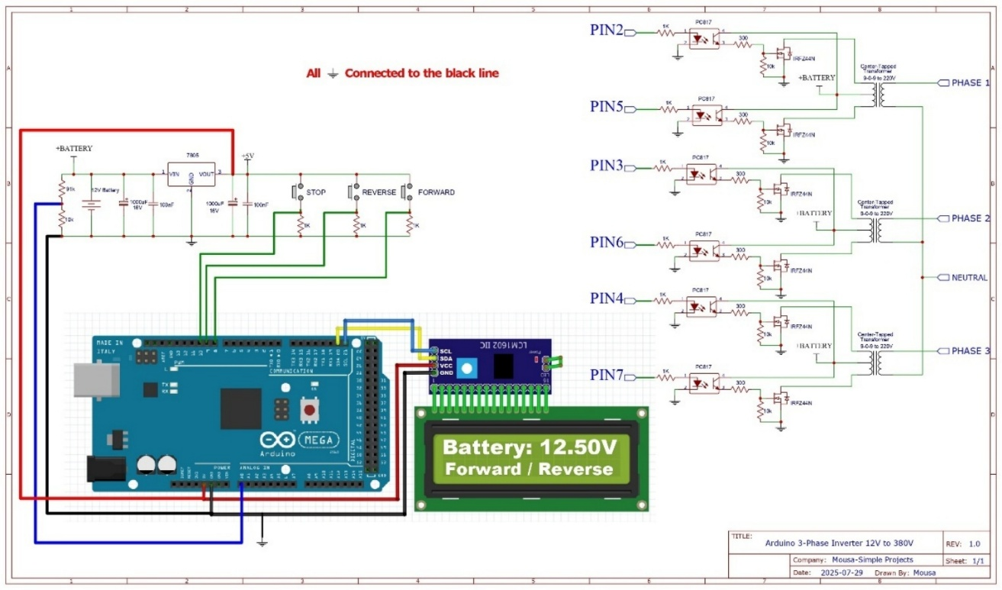
Figure 10.1 Inverter Architecture
Complete hardware schematic with controller, LCD, and inverter interface.

10.2 BMS Architecture
The BMS architecture illustrates the AI-enabled battery monitoring and protection framework. It performs real-time measurement of cell voltage, current, and multi-point temperature using thermocouples embedded in copper busbars. Protection mechanisms include overcharge, over-discharge, overcurrent, and thermal fault isolation. Cell balancing circuits maintain uniform charge distribution across cells. Sensor data is transmitted to the controller using IoT communication protocols for cloud-based monitoring and predictive analytics. Figure 10.2 illustrates the bq76920 BMS hardware interface, detailing the connections for cell sensing, MOSFET protection, and I2C communication with the companion controller.

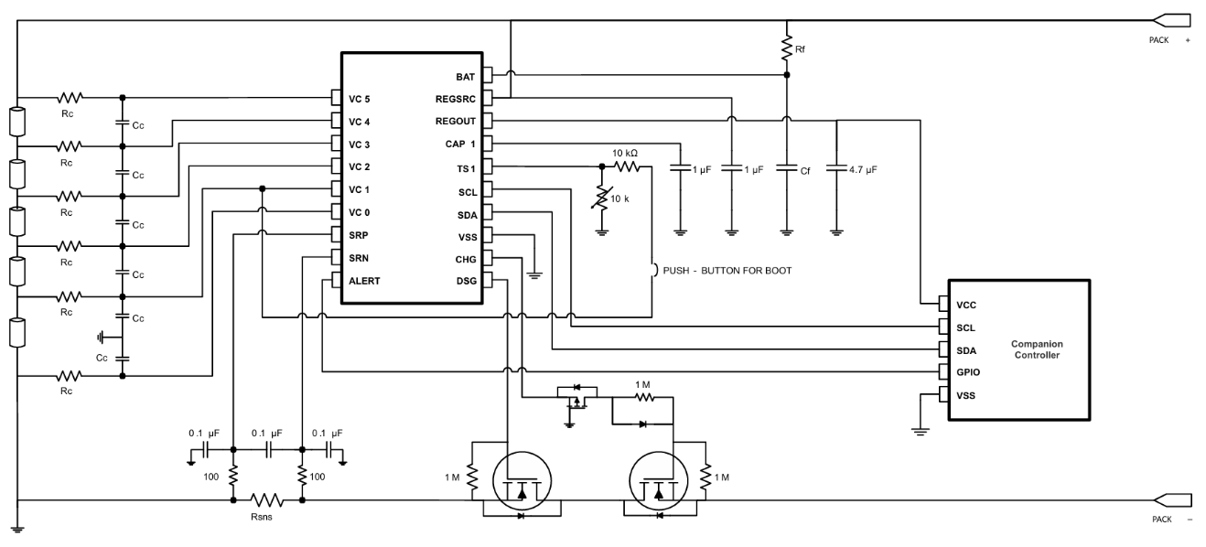
Figure 10.2 BMS Architecture
BMS hardware interface showing sensing and communication connections.

10.3 Lithium Battery Pack
The battery pack is a 12 V, 9 Ah lithium-ion storage unit arranged in a 3p3s configuration. It serves as the primary energy storage source of the system. The pack is enclosed in an IP54-rated acrylic casing with thermal padding for mechanical and environmental protection. Copper busbars are used to improve current conduction efficiency and heat dissipation. Figure 10.3 illustrates the physical prototype of the assembled high-capacity battery pack, showing the cell arrangement and sensory wiring for the BMS.

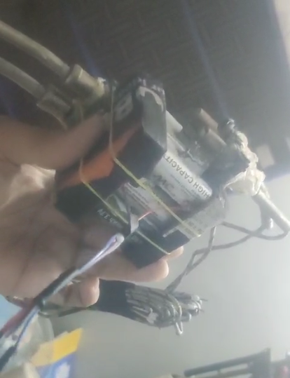
Figure 10.3 Lithium Battery Pack
Physical prototype of assembled battery pack with sensor wiring.

10.4 Inverter Circuit
The inverter circuit uses IRFZ44N MOSFET switching devices and PC817 optocoupler isolation modules. The system operates in 180° conduction PWM mode, producing 50 Hz AC output at approximately 415 V line-to-line voltage. DC link capacitors stabilize bus voltage, while the LC filter reduces harmonic distortion and improves waveform quality. Figure 10.4 displays the experimental hardware setup, showing the breadboard integration of the microcontroller, LCD, and power components during real-time system testing.

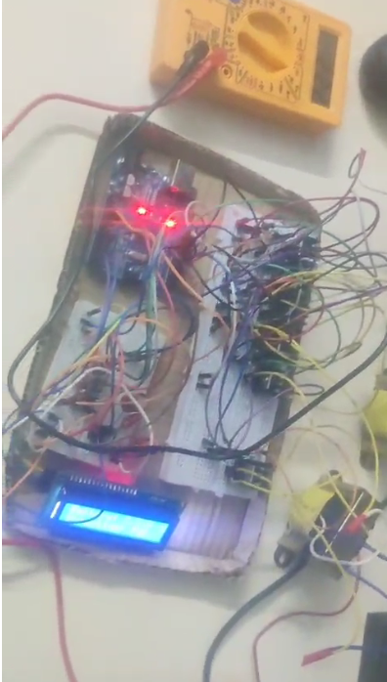
Figure 10.4 Inverter Circuit
Experimental hardware setup for real-time testing on breadboard.

10.5 BMS Circuit
The BMS circuit includes ADS1115 16-bit ADC for voltage sensing and INA219 current sensors for current measurement. MOSFET switches provide protection control, while relay isolation ensures fault safety. Passive cell balancing is implemented using balancing resistors. Firmware-based AI logic enables early fault detection and thermal anomaly monitoring. Figure 10.5 illustrates the breadboard implementation of the bq76920 BMS and ESP32 controller, showing the hardwired connections for communication and power management testing.

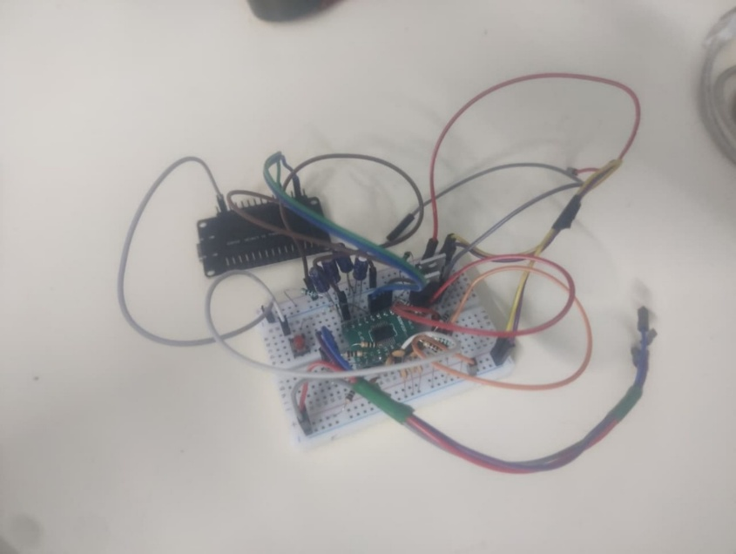
Figure 10.5 BMS Circuit
Breadboard implementation of BMS and controller connections.

10.6 Software UI View
The AI-based monitoring dashboard is developed using Python Streamlit with IoT cloud integration. The interface displays real-time voltage, current, temperature, SOC, SOH, inverter status, and fault alerts. Data is transmitted via MQTT protocol and stored in cloud databases. The platform also supports predictive analytics for energy dispatch and degradation monitoring. Figure 10.6 to 10.8, presents the real-time battery analytics dashboard, highlighting critical health parameters including a State of Health of 96.87% and a degradation index of 0.0313.


Figure 10.6 Software User Interface View – 1
Real-time battery analytics dashboard showing health and degradation metrics.

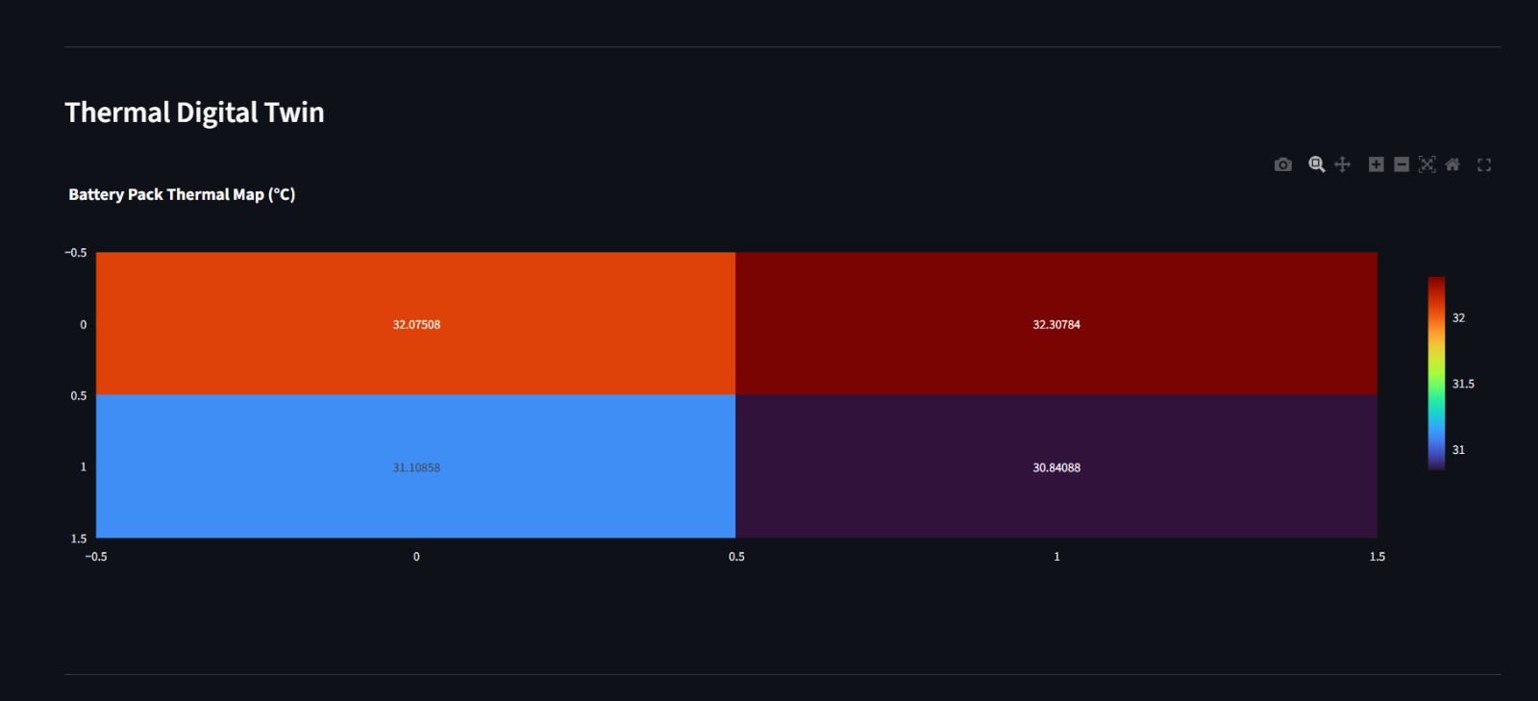
Figure 10.7 Software User Interface View – 2
Real-time battery analytics dashboard showing health and degradation metrics.


Figure 10.8 Software User Interface View – 1
Real-time battery analytics dashboard showing health and degradation metrics.

CHAPTER 10 CONCLUSION
In conclusion, the AI-powered energy-efficient storage system for renewable grids demonstrates an intelligent energy management solution by integrating embedded hardware, power electronics, IoT communication, and machine learning algorithms [1],[2]. The prototype is based on a 12 V, 9 Ah lithium-ion battery storage platform with improved safety features, predictive analytics, and optimized power delivery [3].
The system addresses renewable intermittency through multi-point thermal monitoring using busbar-embedded thermocouples combined with physics-informed neural network (PINN) thermal modeling, enabling rapid fault detection with a response time of approximately 0.4 seconds during abnormal heating conditions [4],[5]. The hybrid GRU-based SOC and SOH estimation model provides accurate battery state prediction, achieving around 98% SOC accuracy and 93% SOH accuracy [6].
Reinforcement learning-based energy dispatch optimization enables intelligent power flow control between solar PV, battery storage, and grid supply, achieving dispatch efficiency of about 91–92% while reducing grid dependency during renewable intermittency [7]. Additionally, the LC harmonic filtering stage enhances inverter waveform quality by maintaining total harmonic distortion below 5% [8].
The prototype is developed at an estimated cost of ₹12,500, with potential reduction to nearly ₹8,000 per unit in mass production. The solution is commercially viable with an expected return on investment of approximately 18 months. Overall, the project establishes a foundation for AI-driven autonomous renewable energy storage platforms supporting smart grids, rural electrification, and sustainable energy infrastructure development [2],[9].

APPENDICES

Appendix A: Mathematical Models

A.1 SOC Estimation Model
Table 12.1.1 SOC Estimation Model
SOC estimation parameters and hybrid method details.
Parameter | Description
Method | Hybrid Coulomb Counting + Voltage Fusion
Nominal Capacity (Cₙ) | 9 Ah
Coulomb Efficiency (η) | 95%
SOC Equation
$$SOC\left(t\right)=SOC\left(t_{0}\right)-\frac{1}{C_{n}}\int_{t_{0}}^{t}{I\left(τ\right)} dτ×$$
Final SOC Calculation:
$$SOC_{final}=0.7 SOC_{coulomb}+0.3 SOC_{voltage}$$
Target Performance: SOC RMSE < 2.5%

A.2 Battery Degradation Model
Table 12.1.2 Battery Degradation Model
Variables used in the battery degradation model.
Variable | Meaning
Q₀ | Initial battery capacity
n | Cycle number
α | Degradation constant (0.001 per cycle)

Model
$$Q\left(n\right)=Q_{0}e^{-αn}$$

A.3 Thermal Diffusion Model
Table 12.1.3 Thermal Diffusion Model
Thermal model symbols for heat generation and diffusion.

Symbol | Description
α | Thermal diffusivity
Q_gen | Joule heating (I²R)
Thermal Dynamics Equation:
$$\frac{∂T}{∂t}=α∇^{2}T+Q_{gen}$$

Appendix B: Dataset Information
Table 12.2.1 Dataset Information
Datasets used for training and validation.
Dataset Source | Purpose
NASA PCoE Dataset (B0005) | Battery degradation learning
PyBaMM Simulation Data | Cycle behavior modeling
Laboratory Experimental Data | Validation (50 cycles)
Training Features
- Pack voltage
- Pack current
- Cell voltage distribution
- Busbar temperature
- Time sequence data

Appendix C: Hardware Components
Table 12.3.1 Hardware Components
Hardware components and specifications for sensing and control.
Component | Specification
Microcontroller | ESP32-WROOM-32 (240 MHz)
Current Sensor | INA219 (±50 A)
ADC Module | ADS1115 (16-bit resolution)
Thermal Sensor | J-type Thermocouple (±1.5°C)
Switching Device | IRFZ44N MOSFET (49 A)
Isolation Device | PC817 Optocoupler
Relay Module | SRD-12VDC

Appendix D: AI Model Architecture
Table 12.4.1 AI Model Architecture
GRU neural network configuration for SOC prediction.
Parameter | Configuration
Network Type | GRU Recurrent Neural Network
Hidden Layers | 2 Layers
Neurons per Layer | 50 Units
Activation Functions | ReLU + Sigmoid
Loss Function | Mean Squared Error
Training Epochs | 100
SOC Accuracy Target | RMSE < 2.5%

Appendix E: Inverter Electrical Performance
Table 12.5.1 Inverter Electrical Performance
Inverter topology and performance characteristics.
Parameter | Value
Inverter Topology | 6-pulse 3-phase MOSFET bridge
Output Voltage | 415 V AC
Frequency | 50 Hz
Switching Frequency | 20 kHz PWM
Total Harmonic Distortion | < 5%
Conversion Efficiency | 88–90%

Appendix F: Communication System
Table 12.6.1 Communication System
IoT communication setup and connectivity details.
Technology | Implementation
Protocol | MQTT
Network | Wi-Fi Connectivity
Database | Astra DB Cloud
Update Support | OTA Firmware Upgrade

Appendix G: Safety Protection Logic
Table 12.7.1 Safety Protection Logic
Protection conditions and system responses.
Condition | System Response
Temperature > 45°C | Relay isolation + Cooling fan ON
Voltage imbalance > 0.2 V | Cell balancing activation
Current > 10 A | MOSFET cutoff
SOC < 20% or > 95% | Protection mode

Appendix H: Software Development Tools
Table 12.8.1 Software Development Tools
Software stack for development, simulation, and visualization.
Layer | Technology
Programming | Python 3.11
Embedded Firmware | Arduino IDE 2.3.2
ML Framework | TensorFlow, Scikit-learn
Simulation | MATLAB, COMSOL
Visualization | Streamlit, Grafana

Appendix I: AI Algorithm Code Snippets
# ======================================================
# CORE BATTERY INTELLIGENCE FUNCTIONS
# ======================================================
def calculate_soc(voltage, v_min=3.0, v_max=4.2):
"""Hybrid SOC estimation using normalized voltage mapping"""
return float(np.clip((voltage - v_min) / (v_max - v_min) * 100, 0, 100))

def calculate_soh(voltage, avg_voltage, temperature):
"""SOH estimation using degradation stress model"""
delta_t = max(0, temperature - 25)
delta_v = abs(voltage - avg_voltage)

soh = 100 - (0.3 * delta_t) - (80 * delta_v)
return float(np.clip(soh, 80, 100))

# ======================================================
# DEGRADATION MODEL ENGINE
# ======================================================
def update_degradation(degradation_index, temperature, imbalance, current):

temp_factor = temperature / 50
imbalance_factor = imbalance / 0.05
current_factor = abs(current) / 10

stress = (
0.45 * temp_factor +
0.35 * imbalance_factor +
0.20 * current_factor
)
degradation_index += stress * 0.00002
degradation_index = min(degradation_index, 1)

return degradation_index

# ======================================================
# THERMAL FAULT DETECTION
# ======================================================
def thermal_fault_detect(temperature):

if temperature > 45:
return "CRITICAL"
elif temperature > 40:
return "WARNING"
return "NORMAL"

# ======================================================
# ENERGY DISPATCH INTELLIGENCE ENGINE
# ======================================================
def compute_energy_dispatch(pack_soc, pack_temp, soh, solar_generation, grid_price):

battery_score = (
0.45 * (soh / 100) +
0.35 * (pack_soc / 100) +
0.20 * (1 - max(pack_temp - 30, 0) / 20)
)

solar_score = solar_generation / 4
grid_score = {"Low":0.9, "Medium":0.6, "High":0.3}[grid_price]

scores = {
"Solar": solar_score,
"Battery": battery_score,
"Grid": grid_score
}

total = sum(scores.values()) + 1e-6

allocation = {k: v/total*100 for k,v in scores.items()}

return allocation

# ======================================================
# OPERATING MODE DECISION ENGINE
# ======================================================
def determine_operating_mode(pack_temp, soh, solar_generation, demand_load, grid_price):

if pack_temp > 42 or soh < 85:
return "Battery Protection Mode"

elif solar_generation > demand_load:
return "Renewable Priority Mode"

elif grid_price == "Low":
return "Grid Charging Mode"

else:
return "Battery Support Mode"

REFERENCES

- Guirguis, J., Abdulmaksoud, A., Ismail, M., Kollmeyer, P. J., & Ahmed, R. "Transformer-Based Deep Learning Strategies for Lithium-Ion Batteries SOX Estimation Using Regular and Inverted Embedding." IEEE Access, Vol. 12, pp. 167108–167119, 2024.
- Hannan, M. A., & How, D. N. T. "Deep learning approach towards accurate state of charge estimation for lithium-ion batteries using self-supervised transformer model." Scientific Reports, Vol. 11, Article 19541, 2021.
- Li, Y., Zhang, X., & Chen, Z. "Thermal Fault Diagnosis Method for Lithium-ion Batteries Based on Electrochemical Impedance Spectroscopy." In IEEE Conference Proceedings, 2025.
- Singh, G., Sharma, P., & Kumar, R. "Transformer-Based Deep Learning Models for State of Charge and State of Health Estimation of Li-Ion Batteries: A Survey Study." Energies, Vol. 17, No. 14, 3502, 2024.
- Zhang, H., Liu, Y., & Wang, J. "State of Charge Estimation for Lithium-Ion Battery Using Transformer with Immersion and Invariance Adaptive Observer." Journal of Energy Storage, Vol. 45, 103768, 2022.
- Qin, Y., Yuen, C., Yin, X., & Huang, B. "A Transferable Multi-stage Model with Cycling Discrepancy Learning for Lithium-ion Battery State of Health Estimation." arXiv preprint, 2022.
- Son, J., & Du, Y. "Model-based Stochastic Fault Detection and Diagnosis for Lithium-ion Batteries." arXiv preprint, 2019.
- Plett, G. L. "Extended Kalman Filtering for Battery Management Systems of LiPB-based HEV Battery Packs." Journal of Power Sources, Vol. 134, pp. 262–276, 2004.
- Hu, X., Jiang, J., Cao, D., & Egardt, B. "Battery Health Prognosis for Electric Vehicles Using Sample Entropy and Sparse Bayesian Predictive Modeling." IEEE Transactions on Industrial Electronics, Vol. 63, No. 4, pp. 2645–2656, 2016.
- Berecibar, M., Gandiaga, I., Villarreal, I., Omar, N., Van Mierlo, J., & Van den Bossche, P. "Critical Review of State of Health Estimation Methods of Li-Ion Batteries for Real Applications." Renewable and Sustainable Energy Reviews, Vol. 56, pp. 572–587, 2016.
- Farmann, A., Waag, W., Sauer, D. U. "Critical Review of On-board Capacity Estimation Techniques for Lithium-ion Batteries in Electric and Hybrid Electric Vehicles." Journal of Power Sources, Vol. 281, pp. 114–130, 2015.
- Severson, K. A., et al. "Data-driven prediction of battery cycle life before capacity degradation." Nature Energy, Vol. 4, pp. 383–391, 2019.
- Yang, F., Wang, D., Xing, Y., Tsui, K. L., & Pecht, M. "Deep Learning-Based Lithium-ion Battery State of Health Estimation." IEEE Transactions on Industrial Informatics, Vol. 16, No. 12, pp. 7821–7830, 2020.
- Lin, X., Perez, H. E., Siegel, J. B., et al. "Online Parameterization of Lumped Thermal Dynamics in Cylindrical Lithium-Ion Batteries for Core Temperature Estimation and Health Monitoring." IEEE Transactions on Control Systems Technology, Vol. 21, No. 5, pp. 1745–1755, 2013.
- Wang, Y., Chen, Z., & Sun, F. "Adaptive Battery Management Systems for Electric Vehicles." Applied Energy, Vol. 205, pp. 1500–1511, 2017.
- Goodenough, J. B., & Park, K. S. "The Li-Ion Rechargeable Battery: A Perspective." Journal of the American Chemical Society, Vol. 135, pp. 1167–1176, 2013.
- Nitta, N., Wu, F., Lee, J. T., & Yushin, G. "Li-ion Battery Materials: Present and Future." Materials Today, Vol. 18, No. 5, pp. 252–264, 2015.
- Akinyele, D., & Rayudu, R. "Review of Energy Storage Technologies for Sustainable Power Networks." Sustainable Energy Technologies and Assessments, Vol. 8, pp. 74–91, 2014.
- Lund, H., et al. "Energy Storage and Smart Energy Systems." International Journal of Sustainable Energy Planning and Management, Vol. 11, pp. 3–14, 2016.
- Zhang, Y., Wang, C. Y., Tang, X. "Cycling Degradation of Lithium-Ion Batteries." Journal of Power Sources, Vol. 196, No. 3, pp. 1513–1520, 2011.
- Xu, B., Oudalov, A., Ulbig, A., Andersson, G., & Kirschen, D. "Modeling of Lithium-Ion Battery Degradation for Cell Life Assessment." IEEE Transactions on Smart Grid, Vol. 9, No. 2, pp. 1131–1140, 2018.
- Khezri, R., Mahmoudi, A., & Hossain, M. J. "Optimal Energy Storage Scheduling in Microgrids." IEEE Transactions on Sustainable Energy, Vol. 10, No. 4, pp. 1813–1823, 2019.
- Mnih, V., et al. "Human-level Control through Deep Reinforcement Learning." Nature, Vol. 518, pp. 529–533, 2015.
- Schulman, J., Wolski, F., Dhariwal, P., Radford, A., & Klimov, O. "Proximal Policy Optimization Algorithms." arXiv preprint, 2017.

────────────── END OF DOCUMENT ──────────────

